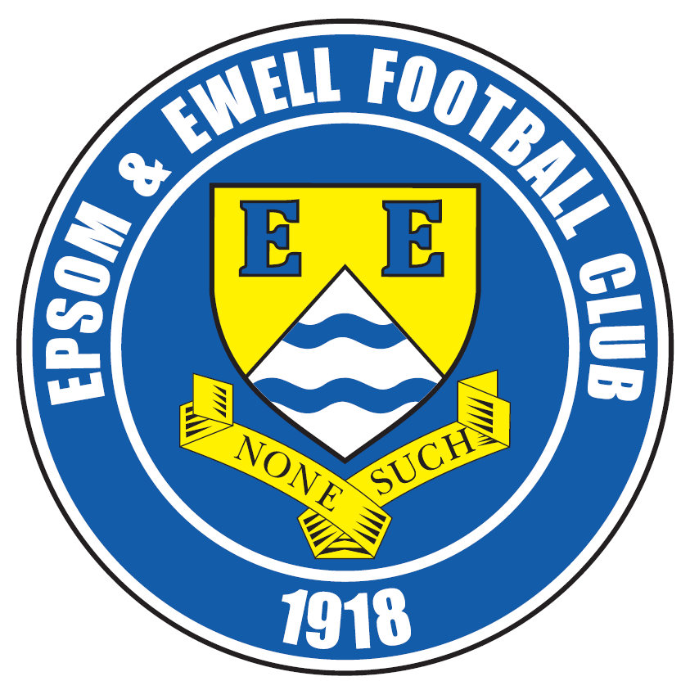 | Epsom & Ewell F.C.  4  v  Erith & Belvedere  Sunday, 16th August 2015
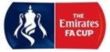
Good afternoon and apologies for bringing you all out on a Sunday! We welcome the players and officials of Erith & Belvedere F.C. to an Epsom home game for the first time since an Athenian League match back in 1976! We also welcome the officials, together with our own regular supporters and our match sponsor today Mike Lovett, one of our Committee Members.

Recent supporters might say that clubs like ours should have met more often, as we aren’t that far apart really. However, historically we have actually met on many occasions, while the mainly wartime Epsom Town club also faced the Deres throughout their brief existence. In fact, out of the 350 or so clubs we have played, Erith & Belvedere sit at number 23 on the all time list, having met on 42 previous occasions. There is much more detail regarding this later on in the programme.

History aside, this is a very important match for both clubs and the first under the new sponsorship of our famous old competition. In all documentation I am now obliged to call it “The Emirates F.A. Cup” but are people still concerned about the addition of a sponsor’s name anymore?

In these modern times, sponsorship has become inextricably linked with all sporting pursuits. As a cricket fan I can recall a fairly large amount of disquiet when Surrey Cricket Club announced back in the eighties that their ground would be called the Fosters Oval for the next fifteen years. However, if you visit the “Kia Oval” today you see a modern sports arena that still retains the character and charm of a Victorian sporting hotbed, which of course it once was. They couldn’t have done this without the financial support that the sponsors provided, so It appears to be a win-win situation and I can confirm that once we get our new ground sorted out we will certainly be enquiring after the possibility of naming rights!

So what of our season so far? Well, we opened up on Saturday with a 2-2 draw at home to Windsor with goals from Rob Hendry on his debut and Kyle Hough with a late penalty. We then travelled to Kiln Brow for our first league match with Redhill since the aforementioned 1976/77 season, where we repeated the result from thirty eight years earlier with a 1-0 win; Kyle scoring again.

Going forward, we were scheduled to be at home to Colliers Wood United on Tuesday, but this is now off and all I can say right now is to please keep checking the club website for details of our next home match. If we are level after 90 minutes today, we would visit Park View Road on Wednesday of this coming week for the replay.

Enjoy the game!

Rich
Did you know we are now on Facebook? www.facebook.com/epsomandewellfc
And we are still on Twitter @EEFCOfficial

Cover photos by Gemma Jarman

- Our boys show off the Dave Wilson Trophy on 4th August

- Sam Currie receives the Dave Wilson Trophy from Chairman Pete Beddoe

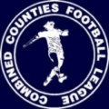
Cherry Red Records
Combined Counties League
Premier Division Table 2015/16
Inc Wednesday 12th August | P | W | D | L | F | A | Pts | GD | H | A
Hartley Wintney | 2 | 2 | 0 | 0 | 12 | 4 | 6 | +8 | 30/1 | 10/10
Raynes Park Vale | 2 | 2 | 0 | 0 | 8 | 2 | 6 | +6 | tba | 28/3
Horley Town | 2 | 2 | 0 | 0 | 7 | 1 | 6 | +6 | 27/2 | 28/12
Colliers Wood United | 2 | 2 | 0 | 0 | 7 | 3 | 6 | +4 | tba | 28/11
Hanworth Villa | 2 | 2 | 0 | 0 | 4 | 1 | 6 | +3 | 21/11 | 23/4
Ashford Town (Mx) | 2 | 2 | 0 | 0 | 3 | 0 | 6 | +3 | 30/4 | 24/10
Westfield | 2 | 1 | 1 | 0 | 2 | 0 | 4 | +2 | 26/3 | 29/8
Epsom & Ewell | 2 | 1 | 1 | 0 | 3 | 2 | 4 | +1 | X | X
Guildford City | 2 | 1 | 1 | 0 | 2 | 1 | 4 | +1 | 5/12 | 2/4
Knaphill | 2 | 1 | 0 | 1 | 2 | 2 | 3 | 0 | 12/3 | 14/11
Camberley Town | 2 | 1 | 0 | 1 | 3 | 6 | 3 | -3 | 16/4 | 20/2
Windsor | 2 | 0 | 2 | 0 | 3 | 3 | 2 | 0 | 2-2 | 23/1
Farnham Town | 2 | 0 | 1 | 1 | 2 | 3 | 1 | -1 | 26/9 | 6/2
Bedfont Sports | 2 | 0 | 1 | 1 | 1 | 2 | 1 | -1 | 13/2 | 31/10
Spelthorne Sports | 2 | 0 | 1 | 1 | 1 | 3 | 1 | -2 | 16/1 | 12/9
Chessington & Hook | 2 | 0 | 1 | 1 | 1 | 3 | 1 | -2 | 7/11 | 19/3
Chertsey Town | 2 | 0 | 1 | 1 | 1 | 4 | 1 | -3 | 17/10 | 5/3
AFC Hayes | 2 | 0 | 0 | 2 | 0 | 2 | 0 | -2 | 19/9 | 9/1
Cove | 2 | 0 | 0 | 2 | 1 | 5 | 0 | -4 | 8/12 | 3/10
Badshot Lea | 2 | 0 | 0 | 2 | 5 | 10 | 0 | -5 | 9/4 | 12/12
Sutton Common Rovers | 2 | 0 | 0 | 2 | 3 | 8 | 0 | -5 | 19/12 | 22/8
Redhill | 2 | 0 | 0 | 2 | 0 | 6 | 0 | -6 | 2/1 | 1-0

Lucky Day? – 16th August
Played 11 - Won 4 Drawn 4 Lost 3 - F 17 A 16 - PPG 1.45 - Average
Club record against Erith & Belvedere
Played 42 - Won 17 Drawn 5 Lost 19 Abandoned 1
For 85 Against 96 - Points per Game 1.33 - Average
Last visit
Saturday 30th October 1976 - Won 5-1 - Athenian League Division One

Club Manager - Glyn Mandeville
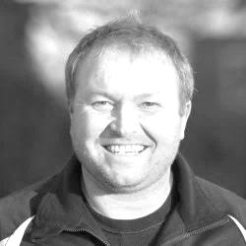
Good afternoon everyone.

Thanks to all that have made the journey here today and hope you enjoy the game.

I have been very happy since the start of the season haveing drawn our first game to Windsor and beating Redhill on Tuesday in a very good performance from the lads, they are showing great progress and seem to be going the right way.

We still have loads to work on and with some suspensions and injuries all cleared up it will be very tough to pick a side today.

This will be a very tough tie and we face a very good Erith & Belvedere side and I would like to welcome all players and staff and supporters for today's game and a safe trip home.

Manders

Club Captain - Sam Currie
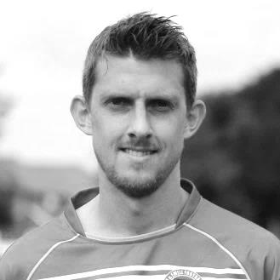
Good afternoon and thank you for joining us this afternoon for the first step of the FA Cup journey.

We welcome the players, coaching staff and supporters from Erith and Belvedere and hope you have a good day out.

For the lads I know there is a certain buzz around the camp to test our capabilities in a competition where we have been drawn against a team we are not familiar with from the old Kent League, but as always the feeling is we would like to have a run in this competition if at all possible.

We are sure the game this afternoon will be a tough one, having played Croydon from the same league in pre-season - however our confidence is high and we are looking to have a good crack at this and hope the promising start we have made in the League can be brought in to today's game.

Our recent success on Tuesday away at Redhill was a good tough battle where I feel we just about shaded it and a typical Houghy goal settled the affair - this should put us in a good position for today's encounter.

As always we are always grateful for the support and we hope you enjoy your afternoon and return to High Road very soon.

Sam

Latest League and Cup Results and Fixtures
Combined Counties League – Friday 7th August
Sutton Common Rovers | 2-3 | Colliers Wood United
Combined Counties League – Saturday 8th August
Ashford Town (Mx) | 1-0 | AFC Hayes
Bedfont Sports | 0-1 | Knaphill
Camberley Town | 0-5 | Horley Town
Chertsey Town | 0-0 | Guildford City
Epsom & Ewell | 2-2 | Windsor
Farnham Town | 1-1 | Chessington & Hook United
Hanworth Villa | 3-1 | Badshot Lea
Hartley Wintney | 5-0 | Redhill
Raynes Park Vale | 3-1 | Cove
Westfield | 0-0 | Spelthorne Sports
Combined Counties League – Monday 10th August
Sutton Common Rovers | 1-5 | Raynes Park Vale
Combined Counties League – Tuesday 11th August
AFC Hayes | 0-1 | Hanworth Villa
Badshot Lea | 4-7 | Hartley Wintney
Chessington & Hook United | 0-2 | Ashford Town (Mx)
Cove | 0-2 | Westfield
Horley Town | 2-1 | Knaphill
Redhill | 0-1 | Epsom & Ewell
Spelthorne Sports | 1-3 | Camberley Town
Windsor | 1-1 | Bedfont Sports
Combined Counties League – Wednesday 12th August
Colliers Wood United | 4-1 | Chertsey Town
Guildford City | 2-1 | Farnham Town
F.A. Cup Extra – Preliminary Round – Saturday 15th August
AFC Hayes | V | Flackwell Heath
Arundel | V | Raynes Park Vale
Badshot Lea | V | Camberley Town
Berkhamsted | V | Hanworth Villa
Binfield | V | Westfield
Chessington & Hook United | V | Crowborough Athletic
Chinnor | V | Hartley Wintney
Colliers Wood United | V | Eastbourne Town
Cove | V | Shrivenham
Latest League and Cup Results and Fixtures
F.A. Cup Extra – Preliminary Round – Saturday 15th August
Croydon | V | Sutton Common Rovers
Horley Town | V | Wick & Barnham United
Knaphill | V | Highworth Town
Potton United | V | Bedfont Sports
Reading Town | V | Chertsey Town
Redhill | V | Pagham
Spelthorne Sports | V | Stotfold
Tadley Calleva | V | Guildford City
Wellingborough Town | V | Ashford Town (Mx)
Windsor | V | AFC Dunstable
F.A. Cup Extra – Preliminary Round – Sunday 16th August
Epsom & Ewell | V | Erith & Belvedere
Thame United | V | Farnham Town
Combined Counties League – Tuesday 18th August
All provisional and dependent on any F.A. Cup replays there may be
Ashford Town (Mx) | V | Spelthorne Sports
Bedfont Sports | V | Sutton Common Rovers
Camberley Town | V | Cove
Chertsey Town | V | Horley Town
Farnham Town | V | Badshot Lea
Hanworth Villa | V | Windsor
Hartley Wintney | V | Guildford City
Knaphill | V | Redhill
Raynes Park Vale | V | Chessington & Hook United
Westfield | V | AFC Hayes
Combined Counties League – Saturday 22nd April
AFC Hayes | V | Knaphill
Bedfont Sports | V | Raynes Park Vale
Chessington & Hook United | V | Chertsey Town
Colliers Wood United | V | Hartley Wintney
Cove | V | Ashford Town (Mx)
Guildford City | V | Westfield
Horley Town | V | Hanworth Villa
Redhill | V | Camberley Town
Spelthorne Sports | V | Farnham Town
Sutton Common Rovers | V | Epsom & Ewell
Windsor | V | Badshot Lea

From behind the goal
Epsom & Ewell 2-2 Windsor
Combined Counties League - Premier Division - Saturday 8th August 2015

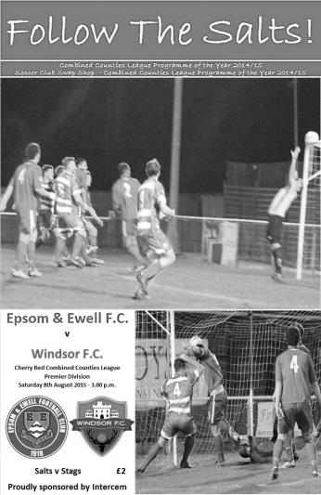
Salts and Stags share spoils in score draw

A healthy crowd of 83 attended High Road on a very warm day to witness a very even opening game of the season.

In the Salts team were three players making their debuts; Craig Hastings and Reisse Griffin came to us from Cheam, while Rob Hendrie joined us from Bookham and all were very busy today. Also, returning to the club for about the ninth time was Dale Marvell, but following a stint at Hanworth Villa he has reincarnated himself as a centre-half and lined up alongside Hastings.

With Hendrie on the left and Griffin on the right of a 4-2-3-1 the spine of the team appeared fairly similar with Michael Eacott in goal, Sam Currie and the now University-free Matt Tanton as the full backs while Dan Dean and Matt Farrell took the centre positions with Kyle Hough playing up front and Daryl Cooper-Smith playing just behind him.

The opening twenty minutes contained little to write home about as both sides appeared to be feeling their way a bit. Eacott had to be alert to block a chance with his legs after a speculative shot had deflected out to one of their strikers after 16 minutes but ten minutes later a good right wing cross from Hough was met at the far post by a Hendrie header which was heading into the far corner until visiting keeper Carl Dennison made a good save to his left and the loose ball was cleared.

On the half hour Griffin and Hough combined well and from the right hand side the latter curled the ball from the edge of the area just beyond the far post. However, it wasn't all great. There were a number of offsides caused either by an early run or a late pass and a few occasions where two of our players jumped for the same ball. Fortunately the visitors didn't take advantage of the mistakes and despite a very even half, we took the lead two minutes into injury time when Currie hooked the ball over from the right and Hendrie met the dropping ball with a volley that kept low and found the net off Dennison's right hand post from twelve yards out.

Any excitement as a result of the goal was tempered by the half time whistle almost immediately afterwards and with seven minutes of the second half played it had been

forgotten completely as Windsor turned the game around in that time. Their equaliser came after 48 minutes when a corner was not cleared and Riccardo Cannon broke through a couple of half challenges to slam the ball into the net from fairly close range.

The second came from a deep cross from the left and the striker just got ahead of Tanton at the far post and on the stretch he volleyed the ball across goal where Adam Turner was there first to knock in the loose ball.

This was a little harsh on our boys who hadn't often looked like conceding in the first half but as the game ticked on, it was beginning to look like this would be the final result. Eacott made a good low save from a dangerous free kick, while Farrell stretched to reach a Marvell set piece but was unable to keep the header down. Then Hendrie latched on to a cross field Hough pass but with the unmarked Farrell waiting in the centre he lashed at the ball from a narrow angle and sent the ball high and wide.

With eight minutes remaining Hough found Hendrie in similar circumstances to his previous attempt but again he rushed the shot and couldn't keep it down. Things were becoming a little concerning, but a minute later a good ball in from the left wing from Hendrie was controlled by Hough and from close range was fouled in the act of shooting wide. Well, that's what the referee saw anyway and he awarded the penalty.

It was a contentious one without doubt, with Dennison saying that he hadn't touched him and some visiting supporters who had another angle saying that the defender had pushed Hough into the keeper. Either way, the penalty was given and a red card for Dennison followed. I don't know whether the visitors had a sub keeper but it made no difference as they had already used their three substitutes anyway and after some delay while the Windsor skipper Adam Kirby donned the jersey and gloves, Kyle did what he usually does and gave him no chance.

The final minutes were mostly played in the Windsor half as we pushed forward in an attempt to claim all three points, but our attempts were unsuccessful and the game ended with both sides unhappy to have earned just the one point each, although no one could honestly say that either side deserved any more than that. Frankly we were fortunate to see four goals really as the number of good chances created by either side were distinctly less than you would usually find in a typical game, but maybe the heat had a little to do with that.

The final word must go to the unfortunate Dennison. In an era when keepers often get more protection at times than they arguably deserve, the law as it stands in this area is brutal and even had he deliberately kicked our player up in the air, a penalty, red card and subsequent one game suspension is clearly far too stiff a punishment, let alone when the decision is a borderline one. Still, we'll probably find ourselves on the wrong end of similar situations at some point in the season, so it's all swings and roundabouts really!

Team: Michael Eacott, Sam Currie ©, Matt Tanton, Craig Hastings, Dale Marvell, Dan Dean, Rob Hendrie, Matt Farrell, Kyle Hough, Daryl Cooper-Smith, Reisse Griffin

Sub: Alex McGregor for Cooper-Smith (70)

From behind the goal
Redhill 0-1 Epsom & Ewell
Combined Counties League - Premier Division - Tuesday 11th August 2015

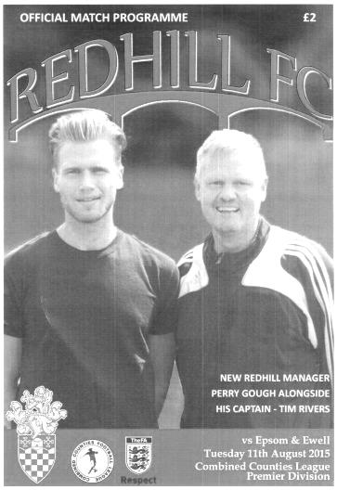
Salts edge Lobsters in local derby

One of Surrey's longest rivalries, dating back over 90 years recommenced on Tuesday evening at Kiln Brow, the current home of Redhill F.C. and we were able to maintain our perfect record on this day with a fourth straight win, courtesy of a great touch and clinical finish from Kyle Hough. But make no mistake, it wasn't easy. This was a tough, competitive fixture on a greasy surface and the home side might well consider that they could have taken the points too.

We made one change to the eleven that started the opening match of the season at Windsor with fit again Savvas 'Agi' Panayiotou coming into a central midfield role and Dan Dean dropping back into defence to cover the absent Dale Marvell. The bench contained no attacking options, although it should be noted that this was the final match in which we would be affected by last season's suspensions with Matt Ferdinando and James Taylor now available again for Sunday's Cup tie with Erith & Belvedere. For Redhill our former winger Matt Robinson lined up against us.

The hosts started slightly the better of the two sides and had a good opportunity in the opening minutes when a low near post free kick was just prodded wide, but the home keeper Curtis was able to jump highest to punch clear as Daryl Cooper-Smith homed in on a teasing Matt Farrell cross in the 10th minute. In fact the game followed this sort of pattern for a while, with half chances at each end, although Dean did well to hold up a Redhill player who had broken through our high line.

We probably should have taken the lead in the 19th minute. Agi ran at goal and then cut onto his left foot and fired a powerful shot at goal which Curtis was able to parry but the incoming Rob Hendry was unable to make a decent contact with the ball although somehow got it back to the waiting Hough who smashed his volley at goal from ten yards, requiring a great save from Curtis, although such are his high standards, Hough will probably feel that he shouldn't have given the keeper a chance to save it at all.

Another shot from Agi required a good save from the livewire Curtis who might be one of the smaller keepers around, but made up for that with an enormous amount of

speed around his area. Incidentally, he didn't play in the defeat at Hartley Wintney three days previously.

On the half hour, our good work to that point was nearly undone as our offside trap broke but Sam Currie got across to hold up the attacker who probably should have shot earlier but chose to try and cut in before slicing a chance wide. In return Cooper-Smith rose at the back post to head a free kick that he had originally won, but was unable to make a decent contact and the ball went wide. We then had another great opportunity in the 43rd minute when Dean's left wing cross was flicked on by Hough and set up for Craig Hastings to strike at goal but from 15 yards he dragged his powerful shot wide. Right on half time a cross - cum - shot from Hendry was tipped over the bar by Curtis and it was clear that we had shaded the first half on points, if not on goals.

We nearly trailed in the 58th minute when a right wing cross was met by an unmarked header but it wasn't a good one and Michael Eacott was able to gather the loose ball and Redhill were made to pay for that when Eacott's long ball up the middle bounced perfectly for Hough to just get his head to it about twenty yards from goal. This touch completely took Curtis out of the game as he had raced out to cover, and Hough simply ran after the ball, reached it ahead of the covering defenders and knocked the ball in with his right foot in the 62nd minute.

He nearly scored again two minutes later when his right wing cross was deflected onto the roof of the net by a defender, but the hosts probably should have been level after 75 minutes when a right wing cross reached the striker in front of goal. However, the cross was a little behind the man and in reaching for the ball he could only hook the chance wide and we had a let off there.

There was an incident after 77 minutes right in front of the dugouts which resulted in a member of the Management team entering the field of play and promptly receiving his marching orders by the referee before we should have wrapped the points up in the 81st minute. Hendry did really well on the left wing and his cross took the keeper out and was there for Cooper-Smith to attack, but not for the first time today he was unable to make a solid contact with the ball and it skidded off his head and went wide from just eight yards out.

Fortunately we weren't made to pay for it and held out fairly comfortably for a win that moves us up to seventh place in the fledgling table. In summary, their keeper was definitely the busier of the two while Eacott didn't really have that much to do, and also had an assist for Kyle's goal! Additionally, our Treasurer was happy as we completed our second match in a row without a booking, so it was a good evening all round if you were an Epsom supporter!

Team: Michael Eacott, Sam Currie ©, Matt Tanton, Craig Hastings, Dan Dean, Savvas 'Agi' Panayiotou, Rob Hendry, Matt Farrell, Kyle Hough, Daryl Cooper-Smith, Reisse Griffin

Subs: none

First Eleven Appearances - (max 2 – including Redhill match – 11/08/15)
Name | Debut | 2014/15 |  |  |  | Career Totals
Name | Debut | App | Sub | Total | Goals | App | Sub | Total | Goals
COOPER-SMITH Daryl | 03/01/2015 | 2 | 0 | 2 | 0 | 11 | 3 | 14 | 6
CURRIE Sam | 04/08/2012 | 2 | 0 | 2 | 0 | 110 | 9 | 119 | 2
DAVISON Conor |  | 0 | 0 | 0 | 0 | 0 | 0 | 0 | 0
DEAN Dan | 02/08/2014 | 2 | 0 | 2 | 0 | 38 | 1 | 39 | 0
DEWAR Ali | 29/10/2011 | 0 | 0 | 0 | 0 | 55 | 35 | 90 | 10
EACOTT Michael | 02/08/2014 | 2 | 0 | 2 | 0 | 48 | 0 | 48 | 0
FARRELL Matt | 02/08/2014 | 2 | 0 | 2 | 0 | 43 | 3 | 46 | 7
FERDINANDO Matt | 20/09/2014 | 0 | 0 | 0 | 0 | 27 | 4 | 31 | 6
GRIFFIN Reisse | 08/08/2015 | 2 | 0 | 2 | 0 | 2 | 0 | 2 | 0
HASTINGS Craig | 08/08/2015 | 2 | 0 | 2 | 0 | 2 | 0 | 2 | 0
HENDRY Rob | 08/08/2015 | 2 | 0 | 2 | 1 | 2 | 0 | 2 | 1
HOUGH Kyle | 14/08/2007 | 2 | 0 | 2 | 2 | 298 | 15 | 313 | 173
MARVELL Dale | 15/01/2000 | 1 | 0 | 1 | 0 | 262 | 45 | 307 | 85
MCGREGOR Alex | 08/08/2009 | 0 | 1 | 1 | 0 | 172 | 57 | 229 | 27
MCKAY Alex | 20/12/2008 | 0 | 0 | 0 | 0 | 85 | 26 | 111 | 8
NORTH Rhys |  | 0 | 0 | 0 | 0 | 0 | 0 | 0 | 0
OLIVER Beckett |  | 0 | 0 | 0 | 0 | 0 | 0 | 0 | 0
PANAYIOUTOU Savvas | 03/01/2015 | 1 | 0 | 1 | 0 | 17 | 3 | 20 | 3
SMITH Matt | 08/08/2009 | 0 | 0 | 0 | 0 | 91 | 43 | 134 | 10
TANTON Matt | 02/08/2014 | 2 | 0 | 2 | 0 | 20 | 4 | 24 | 1
TAYLOR James | 26/08/2013 | 0 | 0 | 0 | 0 | 56 | 8 | 64 | 3

Early Results Grid
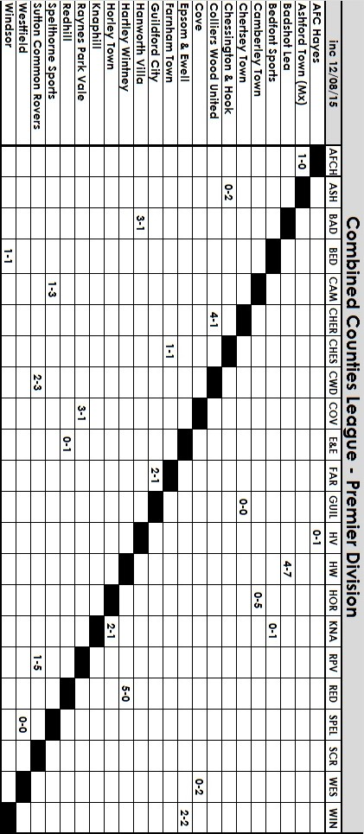

Player Profile – Number 1 – ‘Agi’ Panayiotou
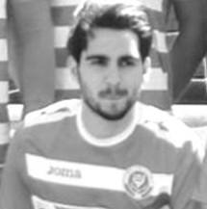
Sam Currie has been busy getting the players to fill in some profile forms and first up in today’s issue is Savvas Panayiotou. Known to all as Agi, he joined us at the start of the year, making his debut against Windsor in January.

Age: 20

Position: Everywhere!

Club supported: Chelsea

Favourite Food: Meat

Favourite Film: Space Jam or Happy Gilmore

Messi or Ronaldo: Messi

Favourite Drink: Water (massive club fine!)

Favourite Ground played at: Allianz Arena

Favourite Spice Girl: Baby Spice – Emma Bunton

Describe the Gaffa in three words: Chauffeur – Funny – Ginger

Agi’s Playing Stats: Debut 03/01/15 - Total Appearances: 20 - Total Goals: 3
Win Ratio (the amount of games he has played in that we have won) 47.37%

Club Records - 16th August
Date | Day | Competition |  | Opponents |  | Scorers
16/08/69 | Sat | Athenian League 2 | H | Ruislip Manor | 2-1 | K.Jolly (2)
16/08/75 | Sat | Athenian League 2 | A | Uxbridge | 1-2 | o.g.
16/08/80 | Sat | Isthmian League 1 | H | Finchley | 1-1 | J.Hunn
16/08/83 | Tue | Southern Combination Cup Final | A | Walton & Hersham | 1-1 | M.Jonas
After Extra Time - Lost 4-5 on penalties
16/08/86 | Sat | Isthmian League 1 | H | Wembley | 1-1 | S.Delaney
16/08/94 | Tue | Isthmian League 3 | A | Canvey Island | 1-2 | N.Webb
16/08/97 | Sat | Isthmian League 3 | A | Wingate & Finchley | 2-1 | T.Boorman, M.Jones
16/08/03 | Sat | Isthmian League 1s | H | Slough Town | 1-4 | G.Morris (pen)
16/08/08 | Sat | F.A. Cup Extra Preliminary Round | A | Eastbourne United | 4-2 | C.Heuston (2), C.West, L.White
16/08/11 | Tue | Combined Counties Premier Division | A | Farnham Town | 0-0
16/08/14 | Sat | F.A. Cup Extra Preliminary Round | A | Hassocks | 3-1 | D.Marvell (2), T.Smith
Historical Decades
Date | Day | Competition |  | Opponents |  | Scorers
60 years ago – Epsom F.C.
20/08/55 | Sat | Corinthian League | H | Slough Town | 2-2 | J.Sorensen, D.Hermitage
50 years ago – Epsom & Ewell F.C.
21/08/65 | Sat | Athenian League 2 | H | Herne Bay | 3-3 | J.Wand, A.Cox, T.Monk
40 years ago – Epsom & Ewell F.C.
16/08/75 | Sat | Athenian League 2 | A | Uxbridge | 1-2 | o.g.
30 years ago – Epsom & Ewell F.C.
24/08/85 | Sat | Isthmian League  Premier Division | A | Walthamstow Avenue | 2-2 | R.Strong, P.Kemp
20 years ago – Epsom & Ewell F.C.
19/08/95 | Sat | Isthmian League 3 | A | Harefield United | 0-0
10 years ago – Epsom & Ewell F.C.
20/08/05 | Sat | Associate Members Trophy Group Match | H | Croydon | 1-0 | L.Gay

History Corner – 16th August
Back before World War Two the football season never started as early as this, so I have little to report until 60 years ago this week when the Doug Whitehead revolution kicked off. Whitehead was a former striker of great repute who scored in the Amateur Cup Final replay when Kingstonian won the competition over Stockton and had been scouting for them, but had a bit of a disagreement with someone over there and started doing the same job for us in 1955. At the same time our Player Coach Pat Lynch was struggling with injury at the end of his own illustrious career and he retired in the March of that year. The club finished at the bottom of the Corinthian League in both the First Team and Reserve sections and it was clear that something needed to be done.

So our club appointed its first ever proper Manager and Whitehead got to work, bringing in some fine players, including former Sutton United and Danish International Jorgen Sorensen and an two up and coming youngsters from Surbiton Town and West Ham ‘A’ by the names of Dave Hermitage and Ted Murphy respectively.

The opening game was a low key affair; a 2-2 draw with Slough Town but we would go on to have two very good seasons before Whitehead retired. Hermitage and Murphy would also have great careers; Hermitage with Sutton United where he also became both Secretary and then Chairman, while Murphy would play for Tooting & Mitcham United, famously scoring at both ends in the F.A. Cup Third Round 2-2 at Sandy Lane against eventual winners Nottingham Forest. He would then have further success at Wimbledon, playing on the winning side at the 1963 Amateur Cup Final against Hermitage and his Sutton United team!

50 years ago this week and following our first ever relegation we hosted Herne Bay in an Athenian League Division Two match but received a rude awakening as we trailed 3-0 at half time before recovering to secure a draw with goals from Jimmy Wand, Alan Cox and Tony Monk.

32 years ago today we travelled to Stompond Lane for the Final of the Southern Combination Cup, where after 90 minutes of goalless action both teams scored in the extra period and we had to go to penalties. Mick Stratford was the unlucky player who missed against future Epsom keeper Ian Stillwell and we lost 5-4, but we never missed a single penalty after that this season and went up to the Isthmian League Premier Division as runners up to Windsor & Eton so it wasn’t all bad! (see programme pictured)

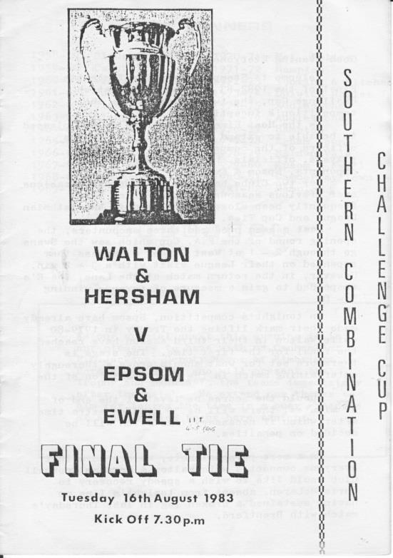
30 years ago this week we looked really good as we led 2-0 at Green Pond Road, the famous old home of Walthamstow Avenue but they retrieved a draw and despite starting the season with two wins to follow this draw, we finished bottom and were relegated after just two seasons in the Isthmian League Premier Division.

Every Opponent A-Z
Over the years we have played many, many different opponents. Exactly how many is a difficult question, as it all depends on your definition. Are Camberley & Yorktown different to Camberley Town, or are Epsom Town different to Epsom F.C. or Epsom & Ewell F.C.?

In my analysis I have classed them as the same team, and will work through them all from A to Z. Some we have played many times, whilst others we have met just once or twice. Enjoy!


Oxford City: Played 13 - W5 D4 L4 - F14 A16 - PPG - 1.46 - Average

Oxford City were, like Nunhead in the previous edition an Isthmian League powerhouse, regularly competing at Amateur football’s top table but never winning the League itself, although they did win the Amateur Cup in 1906.

Following the Second World War they found themselves second best in their town as the upstart Headington United turned professional in 1949 and eventually reached the Football League under the better known name of Oxford United.

By the time we first met them, they were in decline, having been relegated in 1976, bouncing back in 1978 but being relegated to Division One again in 1980. We travelled to their famous White House Ground on 25th October 1980 where a first half goal from Tommy Tuite was enough to secure the points and with Roy Beswick (penalty) and Steve Delaney scoring in the return match on 31st March 1981 it was a perfect start with two wins and no goals conceded!

A scorching Tony Coombe strike kept that record up at West Street the following season, but by the time of the return in April 1982 we had a virtually new squad, following the Pat O’Connell walkout, and required an Alan Ives goal to secure a point in a 1-1 draw.

1982/83 was a season of consolidation for the new squad and signs of progress were limited. However, we held the promotion chasing City goalless twice in ten days in April 1983 and in 1983/84 Steve Hill, Tony Boorman and Mick Stratford all scored in a narrow 3-2 win in the October of what would become our promotion season, although we were held 1-1 in Oxford for the return match in February with Alan Morton scoring our goal.

As regular readers know, our dalliance with the Isthmian Premier League lasted just two seasons and we were back facing them in 1986/87. It was different this time as both were facing a relegation battle; our second in consecutive seasons, and we lost 1-0 at West Street but fought back to win 2-1 on our final visit to the White House ground on 11th April 1987 with two goals from David Jones. It was getting tricky by this stage and although we finished the season well the damage had been done and we went down again, courtesy of an Oxford v Walton & Hersham 0-0 draw, four days after our season had finished, which saved both of them. Hmmm! Even our young defender Matt Elliott, who would go on to greater things, couldn’t save us!

By the time we both met again, we had lost our ground at West Street but incredibly Oxford had suffered a more traumatic situation, as they had been thrown out of their ground at short notice by the owners Brasenose College in 1988 and they had to take a couple of seasons out of football entirely!

They had a nomadic existence for a season or two, moving to Marsh Lane, Marston for the 1993/94 season and haven’t really looked back since. They were accepted back into the Isthmian League for that season too which is where we met once more as members of the Isthmian League Division

Three, winning both games against us. they were destined for better things and were promoted in their first season back behind Cheshunt and Bracknell Town.

Our final meeting came the very next season when we drew them away in the Associate Members Trophy on 20th September 1994. As an aside, isn’t it strange how people think it’s a long way to places like Wembley or Farnham nowadays, when these sort of midweek journeys used to take place all the time! Anyway, it wasn’t a good trip. Against a side containing former Liverpool and Republic of Ireland defender Mark Lawrenson, they were far too good for us and a pair of yellow cards for David Jones (not the same one that scored in 1987) ensured that the opposition would progress 4-1 and by the end of the season they were appearing at Wembley Stadium in the F.A. Vase Final!

Since then they have had further success and currently play in the recently renamed National League South at Step Two. Bizarrely they have also featured in the Conference North in recent seasons. Blyth Spartans and Workington away, anyone!

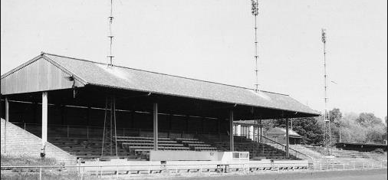
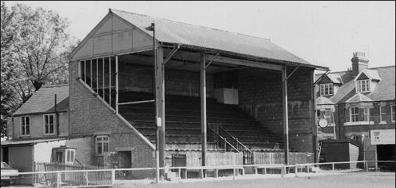
Two old photos of the White House ground courtesy of Bob Lilliman.
Above in 1972 showing the main stand and below in 1975 showing the unusual stand,
along with clock, that was behind the goal but in a corner. Quirky!

Above and Below
Ryman League Division One South Table
incl Wednesday 12th August | P | W | D | L | F | A | Pts | GD
Hastings United | 2 | 2 | 0 | 0 | 9 | 1 | 6 | +8
Corinthian Casuals | 2 | 2 | 0 | 0 | 5 | 0 | 6 | +5
Herne Bay | 2 | 2 | 0 | 0 | 5 | 1 | 6 | +4
Folkestone Invicta | 2 | 2 | 0 | 0 | 4 | 1 | 6 | +3
Guernsey | 2 | 2 | 0 | 0 | 4 | 2 | 6 | +2
Ramsgate | 2 | 2 | 0 | 0 | 3 | 1 | 6 | +2
South Park | 2 | 2 | 0 | 0 | 3 | 1 | 6 | +2
Dorking Wanderers | 2 | 1 | 1 | 0 | 6 | 2 | 4 | +4
Chatham Town | 2 | 1 | 0 | 1 | 5 | 2 | 3 | +3
Molesey | 2 | 1 | 0 | 1 | 5 | 4 | 3 | +1
Walton & Hersham | 2 | 1 | 0 | 1 | 4 | 3 | 3 | +1
East Grinstead Town | 2 | 1 | 0 | 1 | 2 | 2 | 3 | 0
Worthing | 2 | 1 | 0 | 1 | 2 | 2 | 3 | 0
Faversham Town | 2 | 1 | 0 | 1 | 1 | 1 | 3 | 0
Tooting & Mitcham United | 2 | 1 | 0 | 1 | 2 | 4 | 3 | -2
Three Bridges | 2 | 0 | 1 | 1 | 2 | 3 | 1 | -1
Peacehaven & Telscombe | 2 | 0 | 1 | 1 | 2 | 6 | 1 | -4
Chipstead | 2 | 0 | 1 | 1 | 1 | 7 | 1 | -6
Whyteleafe | 2 | 0 | 0 | 2 | 0 | 2 | 0 | -2
Hythe Town | 2 | 0 | 0 | 2 | 0 | 3 | 0 | -3
Sittingbourne | 2 | 0 | 0 | 2 | 2 | 6 | 0 | -4
Walton Casuals | 2 | 0 | 0 | 2 | 2 | 6 | 0 | -4
Whitstable Town | 2 | 0 | 0 | 2 | 1 | 5 | 0 | -4
Carshalton Athletic | 2 | 0 | 0 | 2 | 1 | 6 | 0 | -5
Although normally I would start these summaries by looking at the top of the table, it is far more relevant to both teams today to look at the bottom of the table where the next opponents in the F.A. Cup, Carshalton Athletic currently reside.

Yes, it is early days, and yes one of their defeats was at heavily fancied Dorking Wanderers, while the other was a narrow defeat at Guernsey on a Wednesday night but it’s not the start they would have hoped for. I’m sure there will be representation from Colston Avenue here today, so hopefully we will give them something else to worry about!

I referred to the fact after our Dave Wilson Trophy victory that it might be a long season for Chipstead but with former Salt Kieran Campbell now between the posts they secured a draw with Three Bridges and will hopefully be able to write off the trip to Hastings as an aberration.

I see Guernsey are up near the top. Maybe this will be their year to make a push. I’m sure they probably feel that they should be a Ryman Premier club by now but you just never know!

Above and Below
Combined Counties League Division One Table
incl Wednesday 12th August | P | W | D | L | F | A | Pts | GD
Cobham | 2 | 2 | 0 | 0 | 6 | 2 | 6 | +4
CB Hounslow United | 2 | 2 | 0 | 0 | 3 | 0 | 6 | +3
South Park Res | 1 | 1 | 0 | 0 | 5 | 2 | 3 | +3
Staines Lammas | 1 | 1 | 0 | 0 | 3 | 1 | 3 | +2
Bedfont & Feltham | 1 | 1 | 0 | 0 | 2 | 0 | 3 | +2
Eversley & California | 1 | 1 | 0 | 0 | 2 | 0 | 3 | +2
Epsom Athletic | 1 | 1 | 0 | 0 | 2 | 1 | 3 | +1
Sandhurst Town | 2 | 0 | 2 | 0 | 4 | 4 | 2 | 0
Abbey Rangers | 2 | 0 | 1 | 1 | 2 | 4 | 1 | -2
Dorking Wanderers Res | 2 | 0 | 1 | 1 | 2 | 5 | 1 | -3
Worcester Park | 0 | 0 | 0 | 0 | 0 | 0 | 0 | 0
Farleigh Rovers | 1 | 0 | 0 | 1 | 2 | 3 | 0 | -1
Frimley Green | 1 | 0 | 0 | 1 | 1 | 3 | 0 | -2
Sheerwater | 2 | 0 | 0 | 2 | 1 | 3 | 0 | -2
Banstead Athletic | 1 | 0 | 0 | 1 | 0 | 2 | 0 | -2
Dorking | 1 | 0 | 0 | 1 | 0 | 2 | 0 | -2
Ash United | 1 | 0 | 0 | 1 | 2 | 5 | 0 | -3
For those who were unaware, there have been a few changes down here.

Alton Town have returned West to the Wessex League, while AFC Croydon were promoted but went to the Southern Counties East League instead. Additionally the League has opened up from sixteen to seventeen with the addition of two Reserve teams from Dorking Wanderers and South Park.

Chessington & Hook went up while Frimley Green dropped back down after two seasons but have lost their opening match 3-1 to Staines Lammas.

Again, I know it is early days, but that bottom three tells a sorry tale. All three clubs used to be much higher. Dorking were once in the Ryman Premier while Banstead Athletic were regulars in the Division below and Semi-Finalists in the F.A. Vase in 1997, not yet twenty years ago. As for Ash United, former multiple winners of the Combined Counties League in the nineties, it looks like it may be some time before we see them returning and one wonders how they would cope without the financial support offered by current tenants Badshot Lea which will end in the not too distant future.

It is only fair to point out that even as late in the season as February, Chessington & Hook United were still bottom of this league, yet won promotion, so it is a bit of an understatement to say that there is plenty still to play for here.

The side to watch out for may be CB Hounslow United who will shortly move into a new ground, while it should also be pointed out that the two Reserve sides cannot block one of the three available promotion places, just in case you were wondering.

Just who were the Sunshine Boys?
Maybe it is appropriate that I write this article today as many of our visitors today might also have seen these guys in action at other venues in South London.

The Sunshine Boys were Trevor Lee and Phil Walker, who received the not very politically correct tag from the press in late 1975 when becoming the first two black players to take the field for Millwall. They would have great success in their first season, earning promotion to Division Three in 1975/76 under the Management of Gordon Jago.

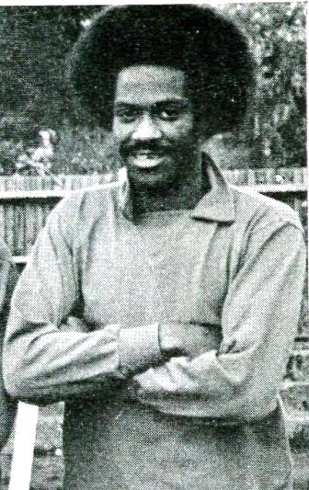
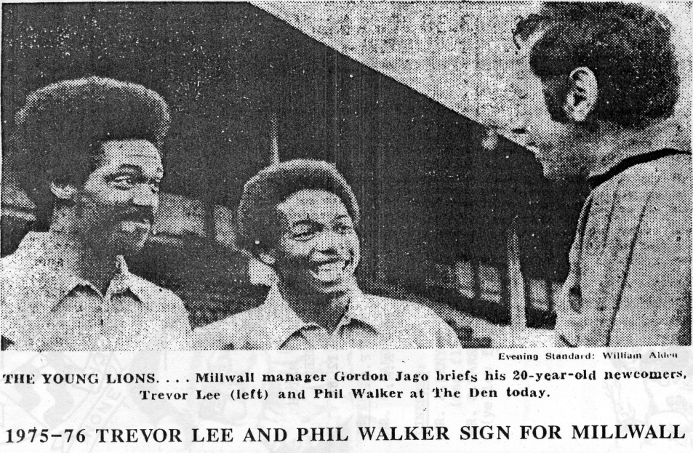
So why are they in our match programme? Well, as anyone who has followed our history will know, before they joined Millwall, both players spent just over a season with Epsom & Ewell and were pivotal members of the squad who made it to Wembley Stadium for the first ever F.A. Vase Final in 1975.

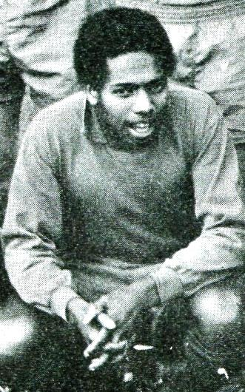
And in July I got the chance to meet with both of them and ask them the sort of questions that they weren’t used to; questions about their time at West Street!

Phil (Parsons Green - 29th August 1954) and Trevor were born just six weeks apart, with Trevor (Lewisham - 3rd July 1954) the older of the pair. When you look at the dates of birth, you realise

that if Phil had been born just three days later, he would have been in a different year and their paths may never have crossed! But cross they did and they both met at Battersea County School, in Culvert Road Battersea. My research tells me that the School had another famous person in its ranks albeit a couple of years lower by way of the actor Timothy Spall (born 27th February 1957).

Both connected with each other well at a time when it must have been difficult growing up as a young black man in South London, but I didn’t ask them any of the usual “race” questions as I felt that they must have had that thrown at them so many times over the years and didn’t want to bore them with more of the same.

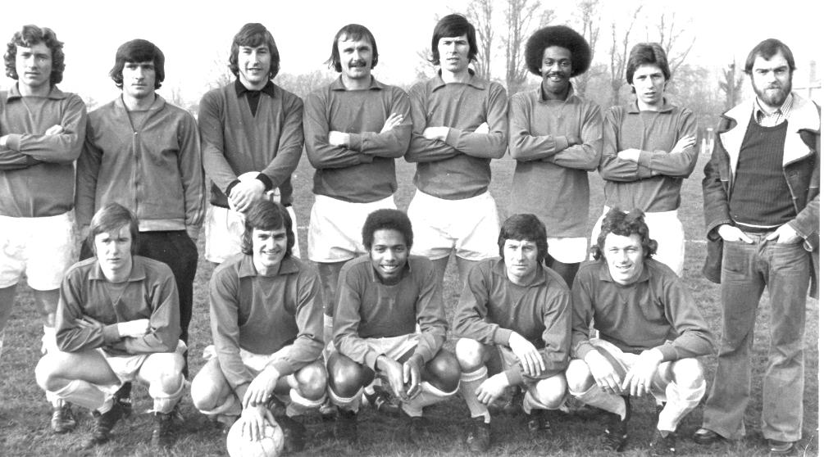
Although both very good at football they went in opposite directions at first. Phil was working in a factory in Acton and got talking to a workmate who was at Wingate F.C. so he went and played with them, scored in his first match and stayed a while. Meanwhile Trevor was at Craven Cottage as was a member of the Fulham Youth Team that won the Youth League Cup with a two-legged victory over Arsenal. However, he was released and found himself tagging along with a friend by the name of Steve Jones, playing down at Cobham under the Management of Gerry Deane who was looking for some more players. Steve had a car which was beneficial at the time as Trevor didn’t drive and Phil joined them there soon after.

In 1974 our club were just beginning to pick themselves up after nearly closing in 1973. The new Manager Pat O’Connell, a former professional at Fulham who had played alongside all of the greats from that era had got into Management at the suggestion of none other than England International footballer Bobby Robson and had assembled a team that was going places. However, O’Connell was always looking to strengthen and on 26th January we played a 3-3 draw with Cobham with both Steve Jones and Trevor Lee playing for the opposition and Lee scored one of their goals.

Clearly impressed with the display, they were asked to join our club in the summer of 1974 and although Jones turned us down, at least to start with, on the opening day of the season Trevor Lee was in our side for the 5-0 win at Lion Sports. Phil had been on holiday in America but joined a month later. However, such was the success we were having at the start of the season that Phil actually spent some time in the Reserves, only making four first team appearances; two of those from the bench, before the end of 1974.

Steve Jones finally joined us in the September, ironically making his debut against Cobham and as you can see by the picture dated 8th February 1975 (on previous page) that all three were regulars by the time of their Vase match against Hornchurch that day. Jones is top left with Trevor in the back row and Phil crouching.
Phil scores our only goal in the F.A. Vase win over Hornchurch on 8th February 1975
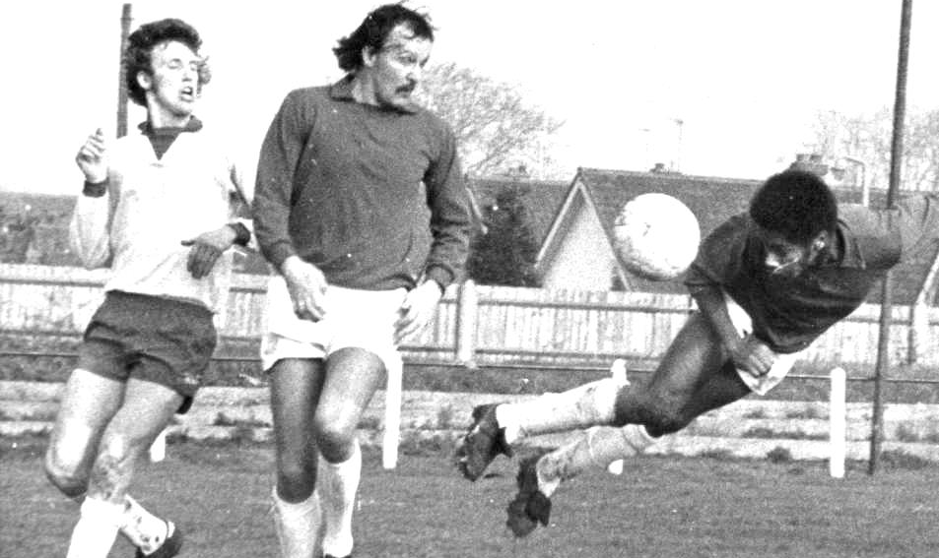

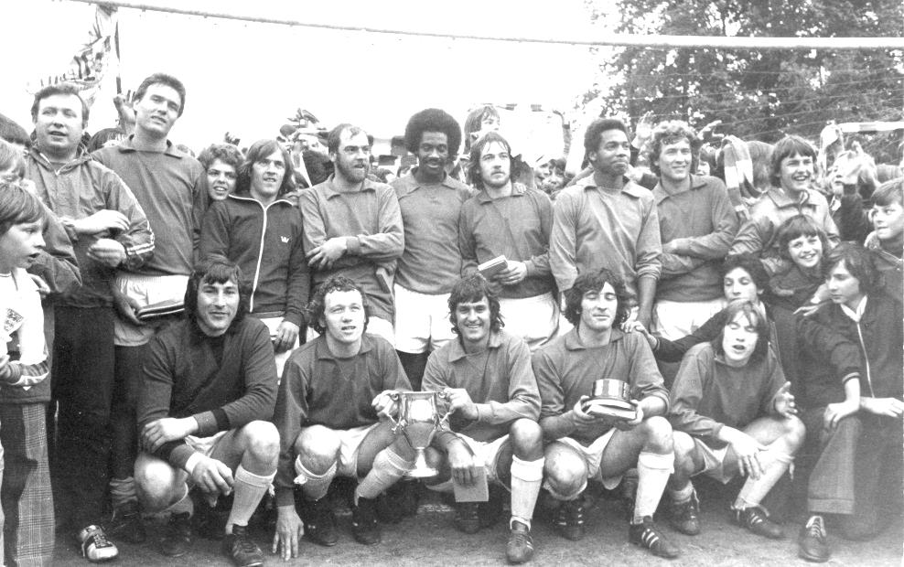
Our boys celebrate with the Surrey Senior League Trophy at West Street in May 1975

Their time at our club was of course extremely memorable. Whilst reaching Wembley was the obvious highlight, we won the League by a distance and earned promotion back to the Athenian League, retained the League Cup against Virginia Water and were runners up in the League Charity Cup when they were beaten by tiredness that day as much as by Chessington United. As an aside I have recently discovered that Hoddesdon Town our Vase conquerors also applied for the Athenian League that season but despite an additional vacancy they were rejected, or we would have met again the very next season. Instead we had to wait forty years for revenge!

Inevitably the club’s success attracted attention and Millwall came calling, initially taking four of our players on trial; Lee, Walker, Tommy Tuite and Willie Bennett. The latter was hampered by injury during his trial period while Tuite incredibly was considered too small at five feet eight inches! Their loss was Epsom’s gain and he would spend the rest of his career proving them wrong! Trevor and Phil thought Tommy was a great player and could have easily made the step up.

Maybe fortunately for us we only lost the two players and on the Monday 22nd September at Champion Hill, home of Dulwich Hamlet, we bowed out in a second replay of an F.A. Cup tie with Isthmian League top flight club Southall & Ealing Borough, who had a young Alan Devonshire in their ranks. Walker scored that day as we fell 5-1 and it proved to be the last ever game for Walker and Lee who signed for Millwall a week later.

Phil left Millwall in 1979 to join Charlton Athletic, then Gillingham on loan in 1983 before travelling around the world to turn out for Eastern AA; a team in Hong Kong.

He then moved to Portugal where he remained for many years, most of which were spent with Boavista before he got his first taste of coaching at S.C. Maia and retiring at the age of 41. He now runs his own Soccer Academy in London.

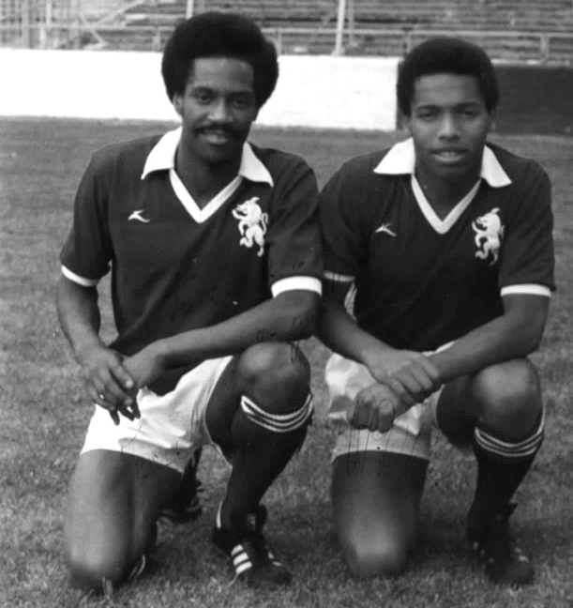
Trevor moved to Colchester United in 1978 and Gillingham in 1981, Bournemouth in 1983/84 where he played alongside George Best, Cardiff in 1984, Northampton Town later that year before returning to Fulham briefly and even Epsom & Ewell for whom he made five further appearances.

He then spent time playing in Ireland, flying out each weekend to play for St Patrick’s for a couple of months but retiring soon after. He became a locksmith and is now a full time carer for his sister.

The best ground that Trevor played at with exception of Wembley Stadium was White Hart Lane, while for Phil it was Benfica’s Stadium of Light. A far cry from West Street, but proof that talent and application can get you anywhere.

Despite being two standard bearers of the game, whether they liked it or not, they were both extremely modest and easy to talk with. I hope we will see them down at an Epsom and Ewell game later this season.

Epsom & Ewell - F.A.Cup Facts & Figures
Today is Epsom & Ewell’s 169th F.A. Cup match!

In that time, we have a record of: Won 66 Drawn 22 and Lost 80 with a Goal Difference of F 297 A 361 - minus 64.

We first entered the F.A.Cup in 1925/26; our second season as a Senior status club, when a missed penalty from our Captain Sid Bristow was costly in a 1-0 defeat to West Norwood, played at their temporary ground in Streatham Road.

Following another first hurdle loss in 1926/27, our first win came on 17th September 1927 when we beat Mitcham Wanderers 3-2 with the first goal that day from Jack Parr (see picture below).

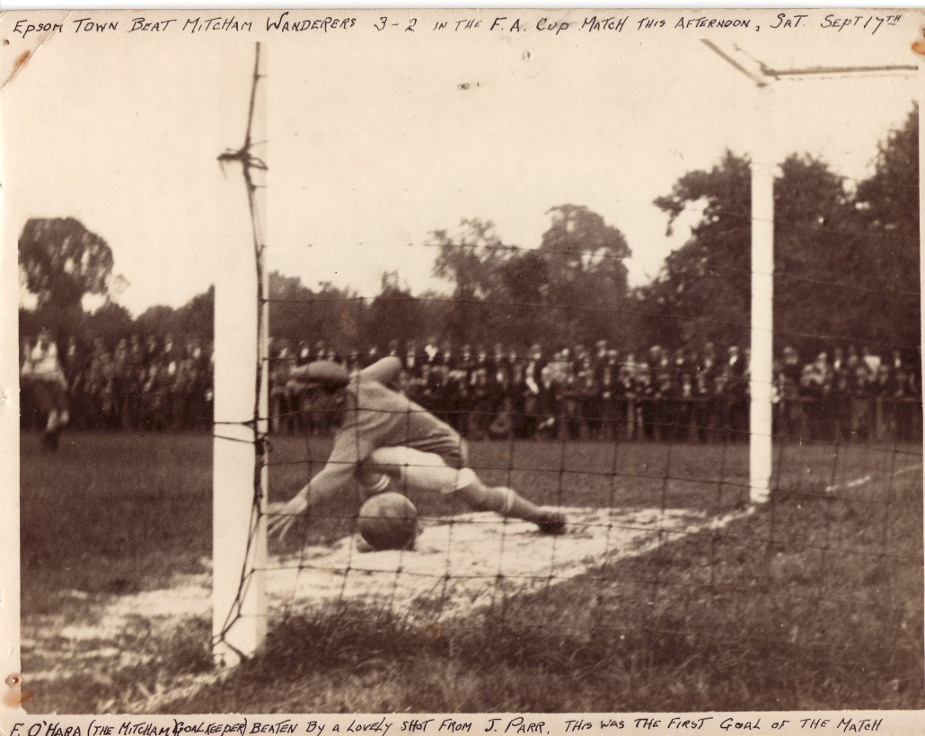
We have reached the First Round Proper on only the one occasion, way back in 1933 when we were defeated 2-4 by Clapton Orient at the Lea Bridge Stadium (see programme across page). However, we have reached the fourth qualifying round on one other occasion in 1980 when being beaten 5-0 by a very good Enfield side that would go on to reach the Fourth Round of the competition that year (last 32).

In addition to those two successful seasons, we have reached the third qualifying round

on eight other occasions, in 1927 and 1929 when we lost to Wimbledon, 1932 when we were defeated at Imber Court by the Met Police, in 1955 when a half time lead turned into a 3-1 home defeat against Margate, in 1964 when Slough Town won 1-0 at West Street, in 1976 when the Isthmian League Champions Enfield required a replay to defeat us, in 1981 when Hastings United won 4-2 at Ewell, and in 1984 when Bognor Regis won a topsy-turvy game 5-4 and went on to reach the Second Round Proper themselves.

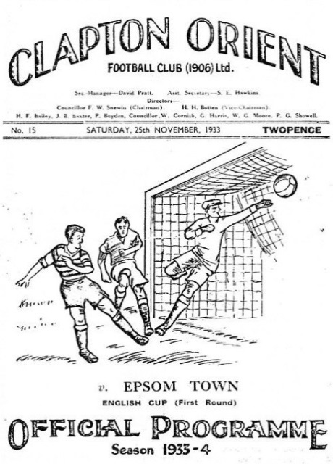
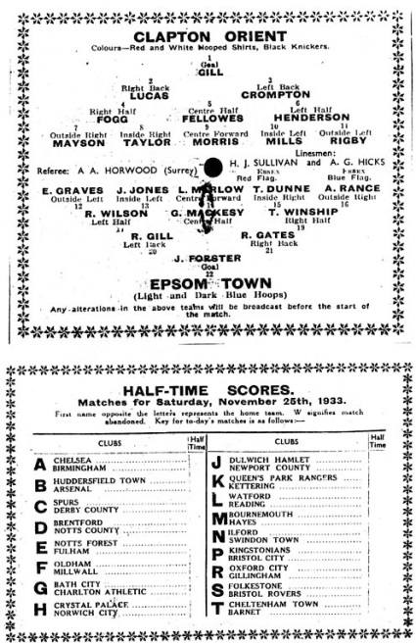
The last time we went as far as the Second Qualifying round was back in 2000 when Horsham defeated us 5-1 at Queen Street. Since that time we have only reached the First qualifying round on five occasions; in 2001 when we crashed 5-0 at Bedfont’s Orchard ground, in 2005 when we lost 1-0 at Camberley, in 2008 when Burgess Hill defeated us 5-2, in 2010 when Hythe Town beat us 2-0 on the way to a First Round appearance at Hereford United, and most recently in 2012 when wins over Arundel and Three Bridges earned us a trip to Bognor Regis where we were beaten 4-0.

Of the ties played so far, we have been at home on 86 occasions and away on 81 with one match, a second replay against Southall & Ealing Borough being played at Dulwich Hamlet’s old Champion Hill ground, when we were beaten 5-1. This was the last match played for the club by Trevor Lee and Phil Walker (see Sunshine Boys article).

When I first wrote this summary in 2012 I advised that replays haven’t come around too often in recent years. However, we have had two in the last two seasons against Whyteleafe and Croydon, although neither ended well. If we were to have a replay again it would be the first time since the mid-seventies (1975-77) that we have had them in three successive years. However, the last replay we actually won was at Imber Court way back in 1989 when we defeated Met Police 2-0. We don’t have many goalless

draws either, with just three in total; at Nunhead in 1932, at Whitstable Town in 1954 and at home to Met Police in 1989.

Our biggest F.A. Cup win came in 1964 when we defeated Marlow 7-1, although we also have an 8-3 win against Beddington Corner in 1929 and a 6-0 win over the Amateur Guildford club in 1949. Conversely we lost 10-1 at Kingstonian in 1947, 0-8 at home to the great Walthamstow Avenue side in 1963, 7-0 at arguably the best non-league side in the country at the time, Barnet in 1988, 8-1 at home to Woking in 1945, and 7-1 twice; at Wimbledon in 1929 and at home to Crowborough Athletic in 2007. Equally concerning is the fact that we haven’t kept a clean sheet in any F.A. Cup tie in the last twelve games, having to go back to a 3-0 win over Shoreham in our first home game at Merstham in 2010.

In terms of attendances, the largest, maybe unsurprisingly was 9,485 at Clapton Orient in 1933 and this is followed by 7,631 at Plough Lane in 1927 and just under 7,500 at the same venue two years later. We had an incredible 5,000 at West Street for the visit of Kingstonian in 1949 (pictured below), 4,600 when we hosted Sutton United in 1937, and finally 4,000 at our old ground for the win over Dorking in 1955.

So which player has played the most times for Epsom in the F.A.Cup? It was “Brother” George Mackesy our Captain throughout the glory years of the thirties played in most with 32. Tommy Tuite was just behind him with 31, and the long-serving legend Dick Wilson played in 26,

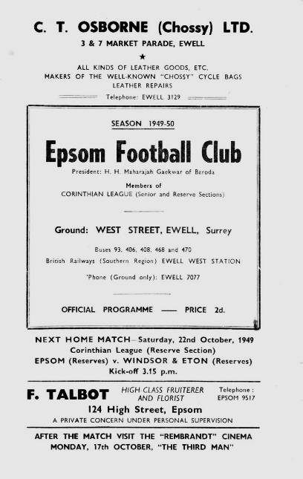
Recent players come nowhere near this. Dale Marvell leads the way with 15, and holds the record for years between F.A. Cup goals as he found the net for us at Moneyfields back in 2000 but didn’t score again in Epsom colours until last season’s win at Hassocks; a gap of just under 14 years! Kyle Hough is next with twelve, with Ben Hayward on 11, while former Captains Jamie Hatfield and Alex Rodrigues have appeared in ten and nine respectively and Alex McGregor also has nine.

For goal scoring, Tommy Tuite comes second again as his tally of 16 is beaten by the second greatest scorer in our history Reg Marlow with 18. Tommy Dunne and Leslie Marlow are next with 11, Billy Williams and Jack Parr scored nine each while Jimmy Jones and Steve Hill both scored eight. From our recent players it is Mark Jarman who has four goals, ahead of Robbie Burns with three and Jamie Summers, Ramzi Bedj Bedj and Charlie West with two. Kyle also has just the two, with one in each of the Whyteleafe games. Let’s hope that figure goes up this afternoon!

Salts Super Six Predictor
The Salts Super Six Predictor is live again today and the tickets are on sale at today’s game to the left of the gate. The ticket is for matches to be played this Tuesday 18th August and will also be on sale against Colliers Wood United if that match goes ahead.

The competition is easy to play and you don’t even have to be at the match! To win, you simply need to predict the results of six matches correctly from the three options, fill in the form and make sure it is back with one of our distributors before the deadline on the ticket. The latest fixtures are shown here.

If you are a club regular, you just need to place your name on the sheet, although if you aren’t, then we’ll need a contact number from you too. We will announce any winners on the website within three working days, so don’t worry, we won’t miss you!

We had a big jackpot winner last year and who knows how much could be won this time! It is currently £93 and you’ll always know the size of the pot before you enter.

Please note that if there is more than one winner, the prize pot would be shared between the winners. All you need to do now is have a go, as many times as you like!

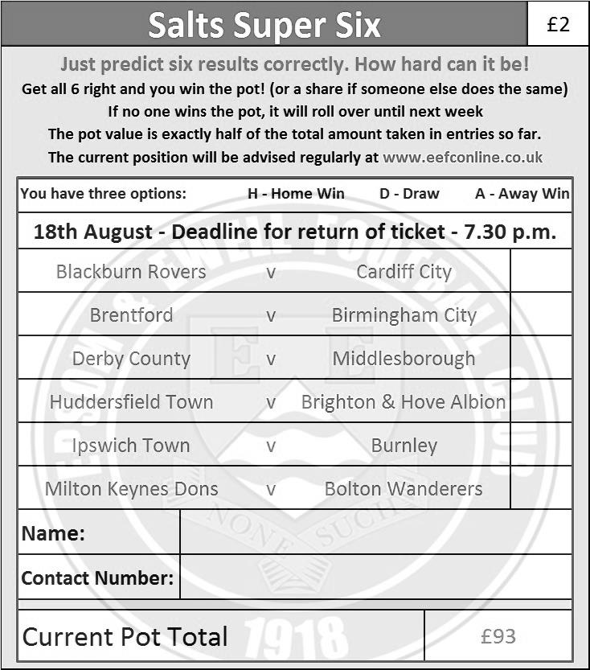

Good luck!

Centre page for results

Centre page for results



Just in case!
We know very little about Erith & Belvedere, having not met since 1976. However, we do have something in common as they have also suffered the loss of their famous old ground, although they have found a novel and maybe even unique way of dealing with the situation.

Upon leaving Park View, they decamped just up the road to Park View Road, former home of Bexleyheath & Welling; a team we met in the F.A. Cup back in 1956, although that match was at West Street. Upon its habitation by the completely separate Welling United in 1977, we twice drew them in the London Senior Cup but again, both times we were at home. Maybe destiny is against us ever playing there, so don’t expect a replay today!

However, if we were to visit we would see an unusual arrangement, as Welling United have all of their administrative buildings and main stand on one side, while Erith & Belvedere effectively “own” the other side. I must admit the idea of sharing a ground with one of our local rivals fills me with concern, but then I suppose our 22 years without a ground isn’t exactly desirable either!

Anyway, just in case we don’t get the chance to visit Park View Road on Wednesday, here are a few pictures of their ground. The larger stand of the two is the Welling United one.

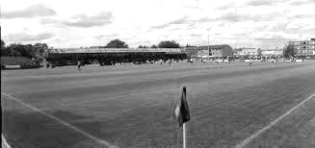
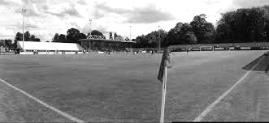

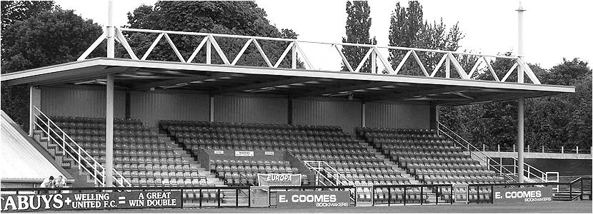
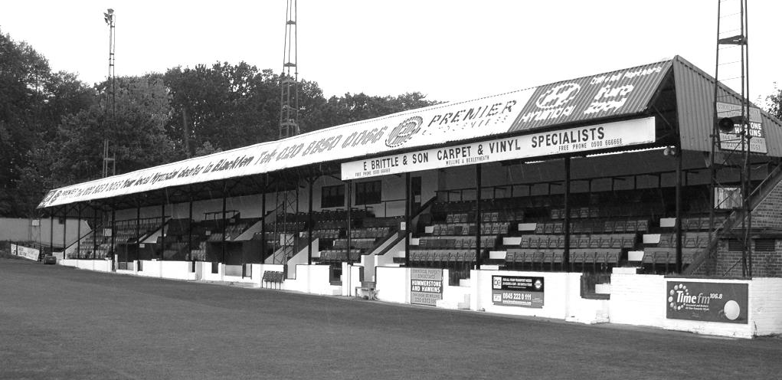
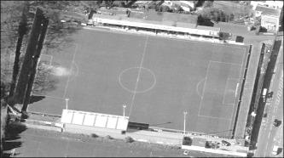

Erith & Belvedere F.C. – History
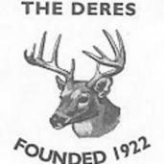
The Deres were formed in 1922 following the restructuring of Belvedere and District FC, a club founded in 1918 (although the original Erith FC, formed in 1885, had played in the inaugural FA Amateur Cup in 1893).

The new club played its first Kent League match on 26 August 1922 at its original home – Park View, Belvedere – losing 3-1 to Chatham. In 1924 the Deres reached the F.A. Amateur Cup Final, losing 3-0 to Clapton at The Den in front of the biggest football crowd in England on a day with a full First Division programme. In the same season they won their first trophy, the Kent Amateur Cup.

The Amateur Cup run earned them a bye to the fourth qualifying round of the FA Cup (equivalent to today’s First Round Proper) in which they lost 2-0 at home to Third Division Reading.

Later in the 1920s several Deres players joined French clubs and one, Stan Hillier, went on to win honours with Cannes and Sête. Cannes won the French Cup in 1932 and were runners-up in the inaugural French League in 1933 with Hillier, who went on to manage them later in the 30s: they have never repeated this level of success!

Apart from two seasons (1929-31) in the London League, the Deres remained in the Kent League until the war. In a league featuring many semi-professional and nursery sides, third place in 1928-29 was their highest finish, but greater success came in cups, reaching successive Kent Amateur Cup Finals in 1934/35. The F.A. Amateur Cup Final was reached again in 1938: although they lost 1-0 in a local derby to Bromley, again at The Den, the 33,346 crowd was the biggest ever for a Deres match.

In 1939 the Deres lost the London Senior Cup Final to a Dulwich Hamlet side fielding seven amateur internationals, and on the outbreak of war four months later they joined the South-East Combination with other amateur clubs continuing through hostilities. Since local industry was important to the war effort, Erith lost few players to the Forces, and became one of Kent’s top clubs. In 1941-42 they won the Kent Senior Cup (the first amateur club to do so for 30 years) and the South East Combination League and Cup double: they dropped only one point, scored 253 goals in 44 games and had a 64-game unbeaten home run ended only by an Army side fielding four full internationals. Former Grimsby Town professional Martin Ruddy scored an astonishing 84 goals and ex-Dartford forward Bob Collins 67, although the circumstances and the standard of the opposition – Forces teams and local rivals weakened by call-ups – make comparison with peacetime records unfair.

Having won the London Senior Cup on the weekend after VE Day with a 5-3 win over Tooting and Mitcham, the Deres became founder members of the Corinthian League, winning the Memorial Shield (League Cup) three seasons in succession (1948-50). Along with Slough and Maidenhead, the Deres remained in the Corinthian League throughout its existence, and in 1963, having finished runners-up in the final Corinthian League table they joined the Athenian on its expansion to three divisions.

It was not a promotion: admission to the Athenian Premier was by invitation not League placing, and Deres were denied the level their league place deserved.

The 1960s saw the heyday of Dennis Crawford, who holds the club appearances record with

over 500, and Colin Johnson, a former West Ham youth team-mate of Bobby Moore whose tally of 227 puts him way out in front in Deres’ goalscoring list.

In the late 1960s the Deres won the Kent Amateur Cup four times in five years and were runners-up in an international tournament in Belgium! They reached the Athenian League Premier Division in 1971 (managed by local-born Roy Dwight, F.A. Cup Final goalscorer with Nottingham Forest in 1959 and of course Elton John’s cousin!) and won the League Cup in 1974. Tommy Ord from the early-70s team played briefly for Chelsea and lined up alongside Pele for New York Cosmos in 1976!

The club chose to return to the Kent League in 1978, but in 1982 entered the Southern League as Kent champions and League Cup finalists, the highlight of Peter Peters’ record 17½ years in charge between 1971 and 1991.

Life was hard for the Deres in the Southern League, with just six top-half finishes and a best placing of 7th under Harry Richardson in 1993. On his departure the club’s fortunes were at a low ebb until the appointment of Mike Acland in 1996.

18 months into Acland’s reign the club could have folded when arsonists destroyed the main stand at Park View on 1 September 1997. The club was based in portakabins for two years – to Acland’s credit results actually improved in these difficult circumstances – before starting a groundshare with Welling United in 1999. Acland departed in 2003, and in 2005 the Deres were relegated, ending a 23-year Southern League stint. This was despite a senior debut season for Chris Dickson, who later played for Charlton and in the Champions League with AEL Limassol, and gained caps for Ghana.

Back in the Kent League, the Deres were in promotion contention until the final day of 2005/06, but were out of the hunt in the following few seasons, apart from an extra-time Kent Senior Trophy final defeat to VCD Athletic in 2009 when they were twice within 17 minutes of the trophy. Micky Collins took over as manager in May 2010 and took the Deres to 5th, then 2nd, and in 2012-13 achieved an epic Kent League title win, clinching the title with a 7-1 win in the final game, scoring 113 league goals in 32 matches and completing a run of scoring in 68 consecutive league games. They beat Corinthian in the League Cup final to complete the double.

But Collins resigned soon afterwards, the double-winning squad dispersed and 2013-14 was a debut Ryman North season to forget: two wins after Martin Ford’s departure as co-manager in October, a 16-game losing sequence and 137 goals against, with relegation confirmed with four games to go.

Season 2014-15 was an unexpected delight for the Deres. After a catastrophic season in the Ryman North, and with a new manager in charge – Matt Longhurst having joined from Corinthian - many thought it would be a season of consolidation. Instead the Deres finished a strong third in the Southern Counties East league, having led the table until Christmas.

They equalled the club record 13-game unbeaten run, set a club record 9 consecutive away wins, and new signing Alfie May started the campaign with five goals on his debut and ended it with 41 goals, just two short of the club’s peacetime record. The bonus was an excellent run to the quarter-finals of the FA Vase: E&B’s best ever Vase run and first appearance in the last 8 of a national competition since the 1946 Amateur Cup. Deres went out, in front of their biggest crowd for 22 years, to eventual winners North Shields, being the only team to keep Shields’ goal machine Gareth Bainbridge off the scoresheet in their entire run.

Erith & Belvedere F.C. – Player Profiles
Dean Nash – 22 – Goalkeeper – Nashy joins us after spending last season at Beckenham Town, he is a great lad to have around the boys with a fantastic work ethic and willingness to learn.

George Kamurasi – 24 – Goalkeeper – George has a fantastic first season at the club, pulling out a heroic performance in the FA Vase against Yaxley, he has a true prescience that commands respect both on and off the pitch.

Allan Matthews – 26 – Defender – Deres veteran and part of the old double winning team in 2013, great attitude, work rate and an incredible throw on, offers options in both attacking and defensive situations.

Ben Wilson – 22 – Defender - Wise footballing head on young shoulders, is a fantastic full back but also has the bonus of offering plenty of attacking options going forward.

Bill Manners – 27 – Defender/Assistant Manager – Bill is a fantastic centre back with a brilliant head and able to read the game, however a nasty injury cut his season short in November 2014, now also serving as Matt Longhurst’s right hand man while he recovers from his injury.

Charlie Burgess – 25 – Defender – Charlie joins us after taking a year out from football the last club he played for at our level was Corinthian, Charlie is a solid defender can break up the opposition when on the attack.

George Benner – 22 – Defender – George is a returning Deres player who knows what it takes to win trophies at this club being a big part of Mickey Collins double winning squad, George joins us after a spell at Thamesmead Town and we are delighted to welcome him back.

George Mitchell – 23 – Defender – George is a player who has proven that he can play at this level of football, George had a very successful spell with VCD Athletic in which he won promotion to the Ryman League and then part of the Ryman North winning side one season later, we are delighted to have George here with us this season.

Joe Jackson – 26 – Defender – Jacko is now in his second season at the club, will always turn up and give 100% at training, he is a fantastic lad to be around and a great asset to the club.

Joe Vines – 34 – Defender – Joe joins us from Greenwich Borough and he brings an old head with plenty of footballing experience to the table, the lads admire him and respect him, solid centre back who when required can get the ball clear but at the same time can play from the back when needed.

Rob Saunders – 19 – Defender – Rob is a solid defender who shows maturity beyond his years, joins us from the new folded Woodstock Sports, he is a player to keep an eye on with a big future ahead of him.

Tom Montgomery – 21 – Defender – Tom is an excellent and solid defender who joins us like Rob from the now folded Woodstock Sports, however he was sadly involved in a horrible car crash and recovering in hospital, we wish Tom a speedy recovery as he was just coming into his prime before his accident.

Brett Ince – 26 – Midfielder – Brett also joins us from Woodstock Sports, he is a solid midfielder who is currently out injured but we look forward to seeing him on the Park View Road pitch very soon.

Colin Richmond – 25 – Midfielder – Winner of both the managers and players play of the year award last season, Colin is a sensible and solid centre midfielder who will always give 100% both on the pitch and the training pitch.

Denzel Gayle – 24 – Midfielder – Denzel is now in his second season at the club after joining early on in the season from Corinthian, Denzel offers plenty of options going both in defence and in attack, he is also a great lad off the bench and a pleasure to have in the team.

George Reed – 17 – Midfielder – Reedy is a product of our Ryman Youth League side last season and made a couple of impressive performances coming on as a sub for the first team in the latter stages of the season, always a solid asset in the Under 18 sides.

Jamie Taylor – 28 – Midfielder – Jamie is a footballer with an impressive work ethic and attitude towards the game, Jamie joins us from Chatham Town but has worked with manager Matt Longhurst before at Corinthian.

Jamie Wood – 37 – Midfielder – Another returning player from the Deres double winning side of 2013, Jamie joins us after a spell at Greenwich Borough and like Joe he brings a wise head for all of our younger players to look up to.

Joe Minter – 26 – Midfielder – A very important part of the club puzzle, Joe is a key utility player on the pitch who can play a number of roles, while off the pitch he is part of the social group that keep the club together and the team spirit high, Joe is a true asset to the club.

Luke May – 33 – Midfielder – The eldest of the three brothers Luke is a natural born leader who can always be heard communicating with his players and trying to drag the team out of any difficult situation they may be in.

Mikey Dalton – 19 – Midfielder – Mikey is a player with maturity well beyond his years, a hard working centre midfielder coming from a family with a strong footballing support, Mikey is a player we can expect to see a lot from in the not so distant future.

Ryan Johnson – 26 – Midfielder – Winner of the prestigious Chairman’s Trophy last season, RJ was a solid asset who could play both centre midfield and centre defence, he was a natural leader and commanded the respect of his team mates both on and off the pitch.

Alfie May – 22 – Striker – With 41 goals last season and the supporter’s player of the year award Alfie is buzzing and ready to go for the new season, a natural goal scorer, Alfie can create a ball out of nothing and produced some moments of brilliance in his first year at the club, long may it continue.

Brendon Cass – 32 – Striker/Coach – Brendon joins as part of Matt Longhurst’s management team but can still put a solid shift in as a player, Brendon is a striker who knows exactly where the goal is with a very successful goal scoring record at his old club Tunbridge Wells.

Chris Hubbard – 30 – Striker – Now in his second season at the club Hubby is a great forward thinking player who offers options both from out wide or going through the middle.

Enoch Adjei – 20 – Striker – Joined the Deres from Phoenix Sports mid-way through last season, Enoch is a great kid with a hard working mentality and will always give his all when given the chance.

George Luck – 18 – Striker – Another product of the Deres Ryman Youth League side, George has also represented the London FA, broke into the first team later on in the season giving a very good account of himself, certainly one for the future.

Ramone McCrae – 25 – Striker – Ramone joins the Deres from our neighbours Erith Town, has played for Peterborough in the football league and is a strong presence to have up front, we are delighted that Ramone has decided to join the club.

Sam May – 31 – Striker – Sam completes the trinity of May’s joining his brothers Alfie and Luke at the club, Sam is a strong utility to striker who can make the difference in high pressure matches.

Matches against Erith & Belvedere
As referred to earlier in the programme, our two clubs have actually met on many occasions with both our First team and Reserves meeting on 42 occasions each. There are some other matches worth reporting, but I’ll get to them later!

The very first time that teams from the town were pitted together was on the 24th September 1927 when the Reserves of each club met in the London League Division One, drawing 2-2 at Park View, their famous old ground. This was the season we entered the London League but the Deres kept their First team in the Kent League, despite being good enough to reach the Amateur Cup Final in 1924, only their third year of existence.

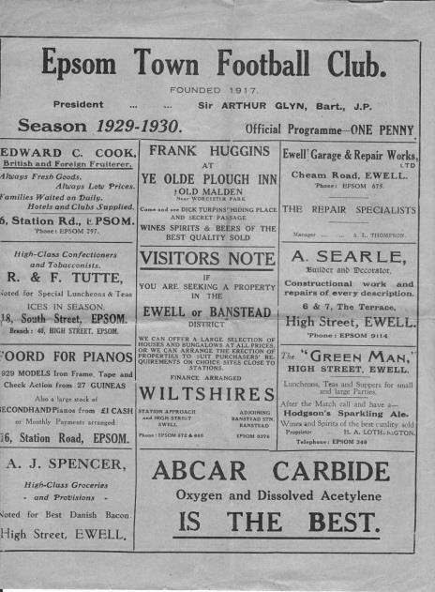
Their first team moved over to the London League for a couple of seasons from 1929-31 and our first ever first team meeting came on Saturday 23rd November 1929, also at Park View where a Jack Parr goal in the first half was not enough as the home side fought back to win 2-1. Ironically, in the return at West Street right at the end of the season on Saturday 3rd May 1930 it was Erith who led at half time by two goals to one, only for the Blues to score three times in the second period to triumph 4-2. Jack Parr scored twice while the other goals came from E.Parker and an own goal. (pictured below are two identical home programmes from those seasons, but not v Erith)

The following season we won 4-1 at Park View on 13th September but required a second half equaliser from George Mackesy to rescue a 1-1 draw in the return match on 21st March.

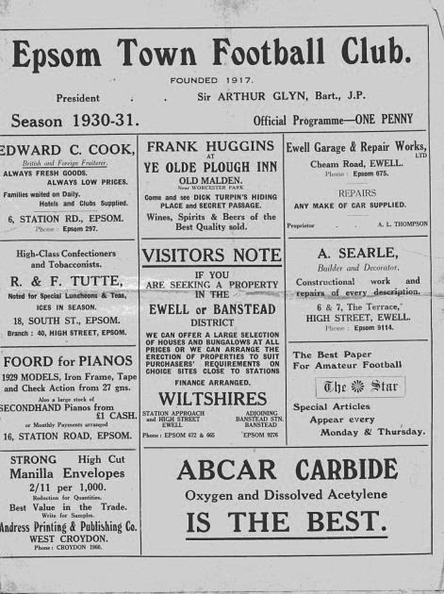
And that was it for a while. Erith & Belvedere took both teams out from 1931 and returned to the Kent League, where they had further success throughout the thirties.

As we move into the nineteen forties I must digress slightly and report on fourteen matches played by Epsom Town against the Deres. Just to recap, in 1939 when we were called Epsom F.C. a second Epsom club were formed, using the name Epsom Town, which to add to confusion was our name from 1922-34. They entered into the Surrey Senior League and shared West Street by agreement.

We hadn’t had a Reserve team for a few years by this stage, preferring instead to share the ground with Ewell & Stoneleigh (1936-38) and Venners Sports (1938-39) but it was felt that the lack of a second team in Epsom was not helping. Our Club Chairman, Charles Pettitt felt that this “nursery”

side would help provide more opportunities for players and get more people involved in supporting the club, especially when the first team were away, so gave it his blessing. He probably didn’t realise that within twelve months he would become inextricably linked with it.

Epsom Town played their first and last Surrey Senior League match on 2nd September 1939, defeating Godalming 2-1 but World War Two was declared the next day and football ceased for a while.

Pettitt didn’t like this arrangement one bit. He had fought in the First World War and was very keen for morale to be kept up in the town of Epsom. He reasoned that if the cinemas could stay open, why couldn’t the football? The standard didn’t matter as long as people had the chance to come and watch.

However, there was a slight problem. The town was rapidly losing people to the war effort and Epsom F.C. were in a slight amount of debt. Pettitt’s opposition came from Solicitor Albert Tuck who said the club would lose more money if it continued through the war and the club voted to close for the duration.

So Pettitt threw in his lot with Epsom Town, offering to help them out where he could. He was a large player in the formation of the Surrey Combination in 1939/40 and after Epsom Town entered it and won, both they and Walton on Thames (pre-merger with Hersham) were invited to join the South Eastern Combination. This was where the big boys played. Dulwich Hamlet, Wimbledon, Woking and Nunhead were all Isthmian League giants and they were joined by Athenian League Sutton United and Tooting & Mitcham United, while from the Kent League came Bromley and Erith & Belvedere who only a few years previously had contested an Amateur Cup Final.

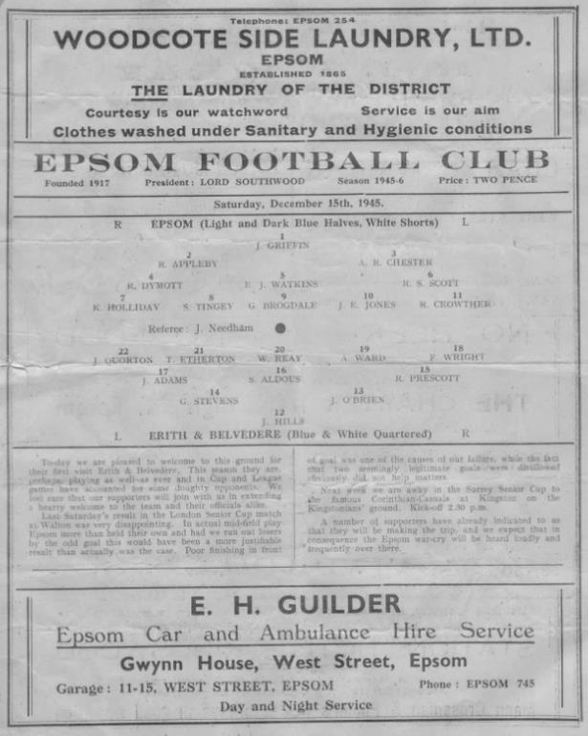
Over the course of five wartime seasons the two teams competed against each other and Epsom Town suffered! We didn’t win a single one of the matches and only drew three of the eleven matches played in the Combination. I say eleven because we also met in the League Cup at Park View. This was a horrible draw as the Deres were rampant that season, wrapping up a League and Cup double and scoring wait for it, 253 goals in around 40 matches!! They got eleven that day without us troubling the scorers!

It must be pointed out that despite their awesome season Epsom Town actually led 2-1 there at half time of our League match before succumbing 6-3 and our local paper reports treated it almost like a win!
Left: A programme from our first post war meeting on 15th December 1945

Unfortunately it wasn’t quite so successful next time we visited as

on 13th February 1943 we were crushed 14-1. Maybe mercifully I have been unable to trace a line up for this match!

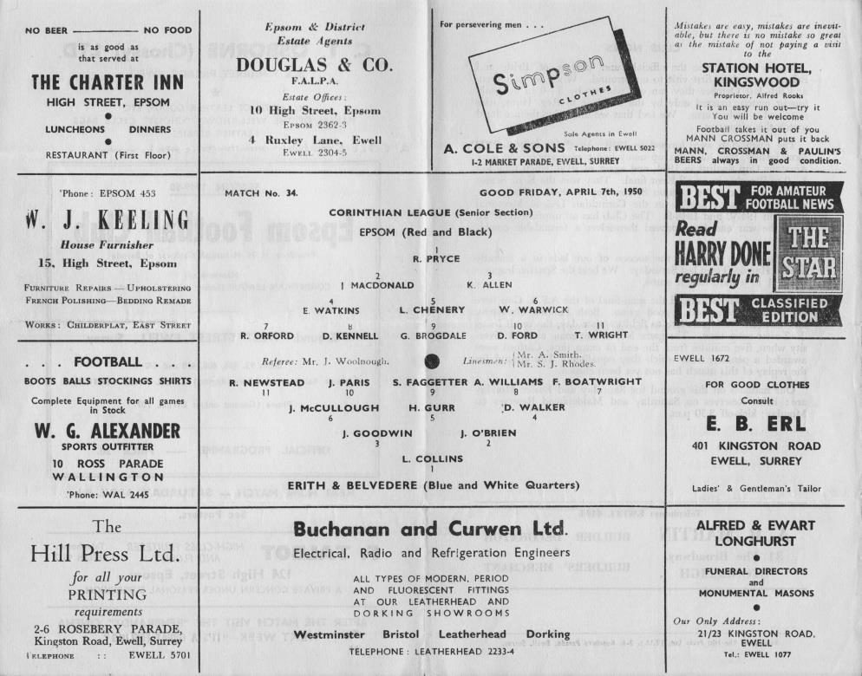
As the war ended, both of these clubs quite liked the idea of matches against the bigger teams and when the Corinthian League was created they both became founder members. Of course for Epsom Town, their days were numbered as Epsom F.C. had reawakened with the aforementioned Albert Tuck as its new Chairman. They reclaimed the West Street ground and sent the Town team via Lavender Avenue, Mitcham and somewhat nearer to home the Old Halleyburians Rugby Club in Ruxley Lane, which is where Erith visited for both a League match and a Subsidiary Cup match; a competition that was actually never completed. A win and a draw for the Deres in addition to a 3-3 draw at Park View ensured that the Town would never have success against them and in 1946 they folded.

The Deres were one of a very rare group of teams that year as they also played Epsom F.C. that season in a friendly at West Street and winning 4-3 (see programme on previous page), but in 1949 our club moved from the London League to the Corinthian and the two clubs remained in regular league competition until 1965 by which time it had merged with the Athenian League (1963).

The first few meetings didn’t go well for us. We lost 3-0 both at home and away in 1949/50 as they finished third, a position they would repeat the following year but not exceed until the 1962/63 season. In that season the Deres had former Redhill players Syd Faggetter and Freddie Boatwright in their line up but the following season they were at Epsom! (see team line up below)

At least the 1950/51 season gave us a win at the end of March by three goals to two, although we were thrashed 7-1 in the earlier match back in December 1950.

The 1951/52 season again resulted in two home wins, whilst in 1952/53 it was two away wins! We also played a friendly in April 1953 as a benefit match for the Deres who had suffered damage to their ground back in the January 1953 floods (see ground and programme below).

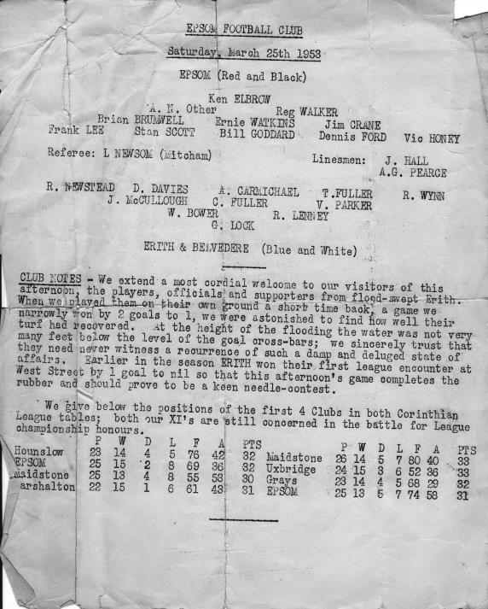
In 1953/54 we also met three times, although this was not the plan! We lost 4-2 at Park View but the return match on 2nd January 1954 was abandoned after just 31 minutes due to fog with the score at 1-1. For those who are interested, Ron Ruffell’s goal is included in the club records. We edged them out in the “third” match by three goals to two in the April. (see programme below).
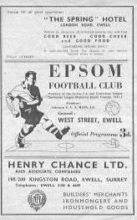
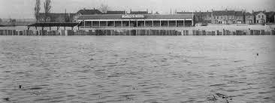
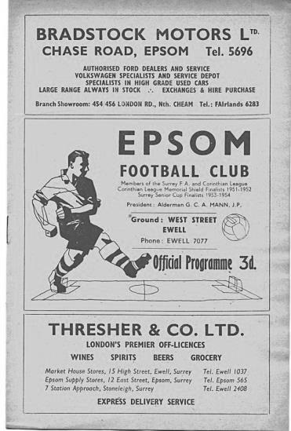
In 1954/55 we lost both games 1-3 at home and 0-6 away as we finished bottom of the league, but the following season under the Management of Doug Whitehead we won both matches 2-0 at Park View with goals from Brian Jenkins and Johnny Berry and 5-0 at West Street with a hat trick from Ted Murphy, one from Norman Ambrose and an own goal. Murphy would go on to have great notoriety at Tooting & Mitcham United and great success at Wimbledon (see history corner).

In 1956/57 we were chasing a Corinthian League and Cup double and won handsomely 8-1 at West Street on 17th November 1956 but the wheels were beginning to fall off towards the end and we were held 1-1 in the April as we eventually ran out of steam and just missed out on both counts (see programme left).

Things began to improve for us towards the end of the fifties. Although we conceded three times in the second half of our next League match to lose 5-2 at Park View, we would win the next five fixtures, 3-0 in the home return and 4-0 and 3-2 in 1958/59.

In 1959/60 we won twice at Park View; the first by 3-2 in the League, and more significantly 3-1 on 5th March 1960 in the first round of the Corinthian League Memorial Shield. We would of course go on to win the Shield this year but the only goal we conceded in the competition was at Park View (see programme below).
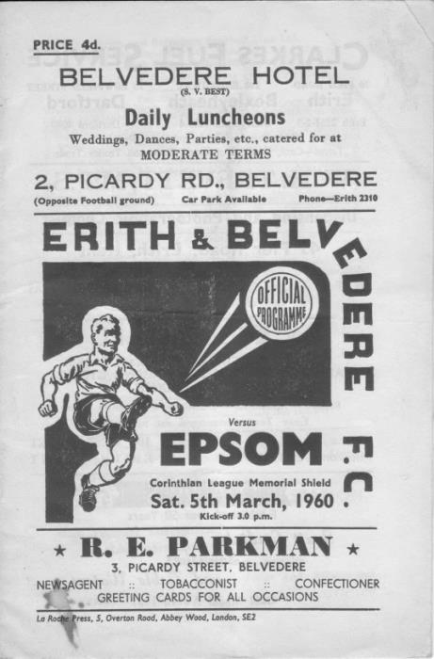
This was very much the high water mark for our club against Erith & Belvedere. Both home games were won in 1960/61 but one draw from the next four matches, all of which oddly were played in August, would be our sole return over the next three years. The two Reserve teams had an unusual situation on the final day of the 1960/61 season when the match was abandoned after 48 minutes due to heavy rain with Epsom leading 3-2. The match never had an opportunity to be replayed and the League table showed us both having played just 29 matches.

As referred to earlier, the Corinthian League merged both with the Athenian League and the Delphian League in 1963, consigning both of those names to the history books. It made no difference to us though as we were a poor team back then and we lost both matches in 1963/64 and despite winning our home match 2-1 in the 1964/65 season we were unable to avoid relegation and our sequence of league matches ended after sixteen seasons.

The Erith & Belvedere away programme for 1963/64 and our
home programme from the following season

We have only met twice since; in 1976/77 after we had been promoted to the top flight of the Athenian League and would be accepted into the Isthmian League at the end of the season.

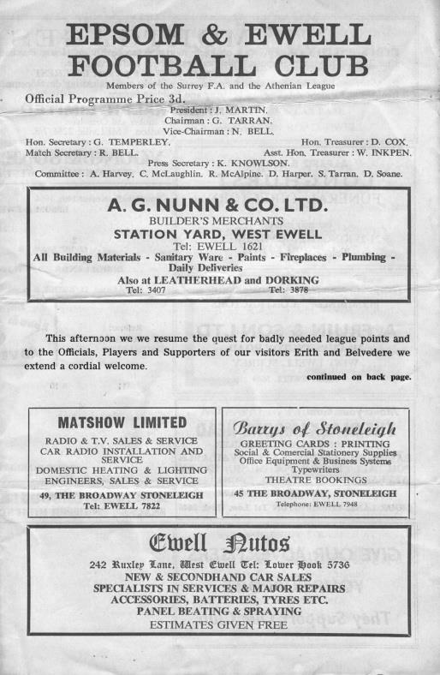
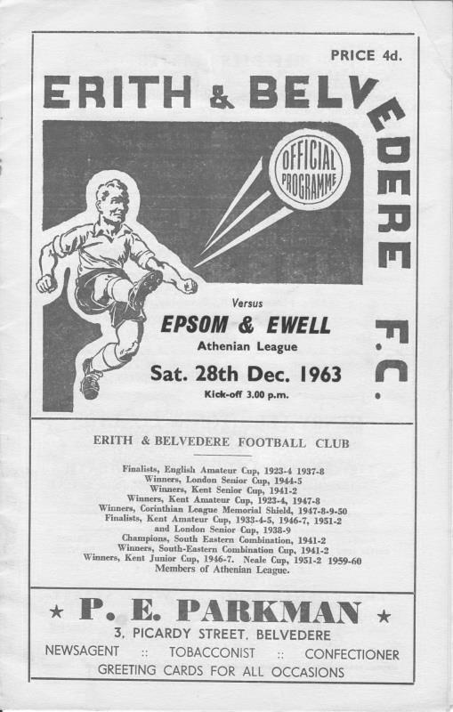
We were on the way up at this point and recorded a fine 5-1 win at home with a Tommy Tuite hat trick leading the way, before a 1-1 draw on 5th March 1977 was the last time our club played at Park View.

Or was it?

The clubs have actually met twice more since then, and although it was not at first team level, the stakes could not have been much higher.

On Wednesday 9th November 1988 the two club’s Youth teams met in the First Round Proper of the F.A. Youth Cup. If that wasn’t big enough, between the time of the 1-1 draw and the replay seven days later, it became clear that the winners of this tie would be at home to the Youth Cup holders Arsenal!

On that day I made my only ever visit to Park View and its rickety, uneven main stand and clubhouse and watched a nervy, tetchy battle between the clubs that ended with our boys scraping through by a goal to nil. Although Arsenal defeated us 11-0 in the next round, the opportunity was only made possible by the win at Erith in the first place.

So there you have it. Exactly 100 football matches in a fairly large nutshell. I think I’ve covered everything!

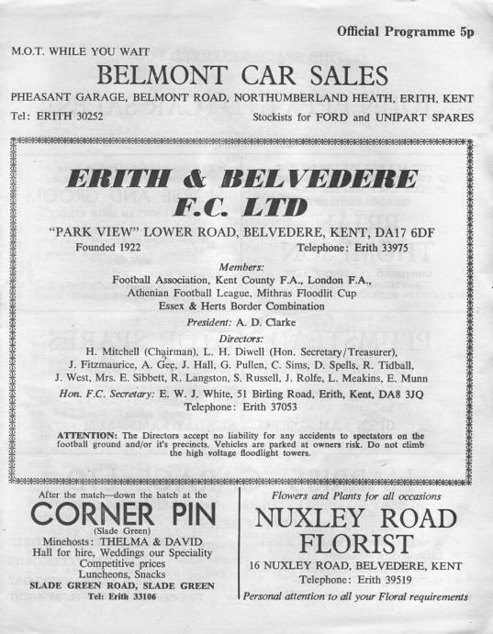
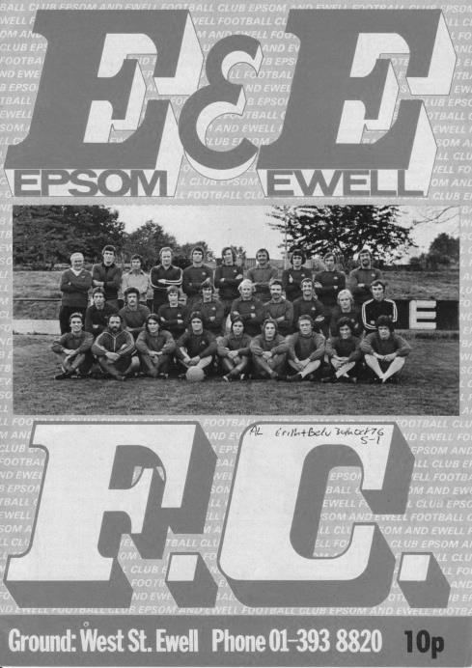
A selection of other programmes.

Above are the pair from the 1976/77 season, while below left is the away F.A. Youth Cup programme from the very last meeting between the clubs in November 1988
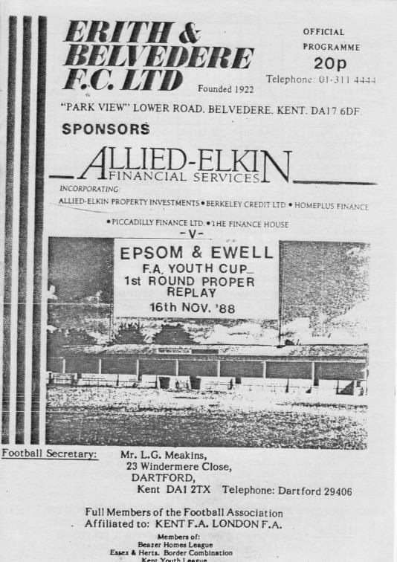

Southern Counties East League - Current Table 2015/16
including Tuesday 11th August | P | W | D | L | F | A | Pts | GD
Corinthian | 2 | 2 | 0 | 0 | 6 | 3 | 6 | +3
Canterbury City | 2 | 2 | 0 | 0 | 3 | 0 | 6 | +3
AFC Croydon Athletic | 2 | 1 | 1 | 0 | 6 | 3 | 4 | +3
Greenwich Borough | 1 | 1 | 0 | 0 | 4 | 1 | 3 | +3
Deal Town | 2 | 1 | 0 | 1 | 4 | 2 | 3 | +2
Cray Valley (PM) | 2 | 1 | 0 | 1 | 3 | 2 | 3 | +1
Ashford United | 1 | 1 | 0 | 0 | 1 | 0 | 3 | +1
Hollands & Blair | 2 | 1 | 0 | 1 | 2 | 2 | 3 | 0
Sevenoaks Town | 2 | 1 | 0 | 1 | 2 | 2 | 3 | 0
Fisher | 2 | 1 | 0 | 1 | 3 | 4 | 3 | -1
Lordswood | 2 | 1 | 0 | 1 | 1 | 3 | 3 | -2
Beckenham Town | 1 | 0 | 1 | 0 | 3 | 3 | 1 | 0
Crowborough Athletic | 1 | 0 | 1 | 0 | 1 | 1 | 1 | 0
Tunbridge Wells | 2 | 0 | 1 | 1 | 1 | 2 | 1 | -1
Holmesdale | 0 | 0 | 0 | 0 | 0 | 0 | 0 | 0
Croydon | 1 | 0 | 0 | 1 | 0 | 1 | 0 | -1
Erith Town | 1 | 0 | 0 | 1 | 1 | 3 | 0 | -2
Erith & Belvedere | 2 | 0 | 0 | 2 | 2 | 6 | 0 | -4
Rochester United | 2 | 0 | 0 | 2 | 1 | 6 | 0 | -5
Our opponents will surely be one of the challenging teams this season but got off to a bizarre start at Mayfields, the home of AFC Croydon Athletic, missing two penalties and having two sent off in a 3-0 defeat, with all goals coming inside the opening twenty minutes!

However, on Tuesday they found matters equally difficult against Corinthian and lost 2-3 at Park View Road.

Elsewhere, it is interesting to see the resurgence of Canterbury City, who have suffered a miserable twenty years, lost their ground, folded, reformed and now ground share, originally with Herne Bay but now Ashford United. Surely a city of this size can accommodate a Senior football club. Maybe it’s the biggest in the county without one, bigger even than Epsom!

Greenwich Borough will surely fancy their chances this year, having a good season hampered back at the start by an incredible F.A. Cup progression to the Fourth Qualifying Round where Worcester City ended their run. Of course tonight’s opponents and Ashford United too, last year’s runners up, will also hope to be involved in the battle to go up.

This league is consistently very strong and I haven’t even mentioned Tunbridge Wells, who were at Wembley Stadium in the F.A. Vase Final just two years ago. Almost every side that goes up from this league survives in the Ryman League and it will be interesting to see how Phoenix Sports fare this season.

It is also important to note that while this league keeps promoting clubs with few returns, its footprint moves gradually east and with Croydon now considered part of the League, we, Horley and Redhill may one day find ourselves playing these teams on a regular basis.

CCL Premier Division Club Directory
A.F.C. HAYES Telephone: 0208-845-0110 - Ground: Farm Park, Kingshill Avenue, Hayes, Middx. UB4 8DD - Colours: Blue and White Stripes/Blue/Blue

ASHFORD TOWN (Mx) Telephone: 01784-245908 - Ground: The Robert Parker Stadium, Short Lane, Stanwell, Middx. TW19 7BH - Colours: Tangerine & White Stripes/Black/Tangerine

BADSHOT LEA Telephone: 01252-320385 - Ground: Ash United FC, Shawfield Stadium, Youngs Drive, Shawfields Road, Ash, Hampshire. GU12 6RE - Colours: Claret/White/Claret

BEDFONT SPORTS Telephone: 0208-831-9067 - Ground: Bedfont Sports Club, Hatton Road, Bedfont, Middx TW14 8JA - Colours: Red & Black Hoops/Black/Red & Black Hoops

CAMBERLEY TOWN Telephone: 01276-65392 - Ground: Krooner Park, Wilton Road, Camberley, Surrey. GU15 2QW - Colours: Red & White Stripes/Blue/Red

CHERTSEY TOWN Telephone: 01932-561774 - Ground: Alwyns Lane, Chertsey, Surrey. KT16 9DW - Colours: Royal Blue & White Stripes/Royal Blue/Royal Blue

CHESSINGTON & HOOK UNITED Telephone: 01372-602263 - Ground: Chalky Lane, Chessington, Surrey. KT9 2NF - Colours: Blue/Blue/Blue

COLLIERS WOOD UNITED Telephone: 0208-942 8062 - Ground: Wibbandune Sports Ground, Robin Hood Way, Wimbledon. SW20 0AA - Colours: Blue & Black Stripes/Black/Black

COVE Telephone: 01252-543615 - Ground: Oak Farm Fields, 7 Squirrel Lane, Cove, Farnborough, Hampshire. GU14 8PB - Colours: Yellow/Black/Yellow

EPSOM & EWELL Telephone: 01737-553250 - Ground: Chipstead FC, High Road, Chipstead, Surrey. CR5 3SF - Colours: Royal Blue & White Hoops/Royal Blue/Royal Blue & White Hoops

FARNHAM TOWN Telephone: 01252-715305 Ground: Memorial Ground, Babbs Mead, West Street, Farnham, Surrey. GU9 7DY Colours: - Claret & Sky Blue /White/ Claret & Sky Blue

GUILDFORD CITY Telephone: 01483-443322 - Ground: The Spectrum, Parkway, Guildford, Surrey. GU1 1UP - Colours: Red & White Stripes/Black/Black

HANWORTH VILLA Telephone: 0208-831-9391 - Ground: Rectory Meadows, Park Road, off Hounslow Road, Hanworth, Middlesex. TW13 6PN - Colours: Red & White Stripes/Black/Black

HARTLEY WINTNEY Telephone: 01252-843586 - Ground: Memorial Playing Fields, Green Lane, Hartley Wintney, Hants RG27 8DL - Colours: Orange & Black/ Orange /Orange

HORLEY TOWN Telephone: 01293-822000 - Ground: The New Defence, Anderson Way, Court Lodge Road, Horley, Surrey. RH6 8SP - Colours: Claret & Sky Blue/Claret/Claret

KNAPHILL Telephone: 01483-475150 - Ground: Brookwood Country Park, Redding Way, Lower Guildford Road, Knaphill, Surrey. GU21 2AY - Colours: Red/Black/Red

MOLE VALLEY SCR Telephone: 01932-866386 - Ground: Cobham FC, Leg O’Mutton Field, Anvil Lane, Downside Bridge Road, Cobham, Surrey KT11 1AA - Colours: Yellow/Black/Black

RAYNES PARK VALE Telephone: 020-8540-8843 - Ground: Prince Georges Playing Field, Grand Drive, Raynes Park, London. SW20 9NB - Colours: Blue/Blue/Red

REDHILL Telephone: 01737-762129 - Ground: Kiln Brow, Three Arch Road, Redhill, Surrey RH1 5AG - Colours: Red and White Stripes/Black/Red

SPELTHORNE SPORTS Telephone: 01932-961055 - Ground: Spelthorne Sports Club, 296 Staines Road, Ashford Common, Ashford, Middx. TW15 1RY - Colours: Light & Dark Blue/Dark Blue/Light Blue

WESTFIELD Telephone: 01483-771106 - Ground: Woking Park, Kingfield Road, Woking, Surrey. GU22 9BA - Colours: Yellow/Black/Black

WINDSOR Telephone: 01753-860656 - Ground: Stag Meadow, St Leonards Road, Windsor, Berks SL4 3DR - Colours: Red/Red/Red

Match and Ball Sponsorships – 2015/16
Opponent | Date | Match Sponsor | Ball Sponsor
Hoddesdon Town | 18/07/15 | Geoff Dyke
Windsor | 08/08/15 | Club President Stella Lamont
Erith & Belvedere | 16/08/15 | Mike Lovett
Carshalton Athletic | 30/08/15 | Provisional - Only if we defeat Erith & Belvedere
Raynes Park Vale | 31/08/15 | Provisional - EEFC Management Committee
AFC Hayes | 19/09/15
Farnham Town | 26/09/15
Chertsey Town | 17/10/15
Dorking Wanderers | 20/10/15 | Surrey Senior Cup
Chessington & Hook United | 07/11/15
Hanworth Villa | 21/11/15
Guildford City | 05/12/15
Cove | 08/12/15
Sutton Common Rovers | 19/12/15
Redhill | 02/01/16
Spelthorne Sports | 16/01/16
Hartley Wintney | 30/01/16
Bedfont Sports | 13/02/16
Horley Town | 27/02/16
Knaphill | 12/03/16
Westfield | 26/03/16
Badshot Lea | 09/04/16
Camberley Town | 16/04/16
Ashford Town (Mx) | 30/04/16
Colliers Wood United | tba | Originally 18/08/15 but Chipstead now have a Cup tie
For League, League Cup and Surrey Senior Cup Matches:
Match sponsorship - £40.00 Match ball sponsorship - £25.00. Combined £55.00.
For F.A. Cup and F.A. Vase matches:
Match sponsorship - £50.00 Match ball sponsorship - £30.00. Combined £65.00.

Sponsorship includes: (x2 for match, x3 for match and ball)

Admission, programmes, hospitality and advertising and mascot for the day (if required).
If you are interested, just speak to a Committee Member, or drop me an email at: richard.c.lambert@gmail.com


We also thank our Kit Sponsors INTERCEM

Player Sponsorship
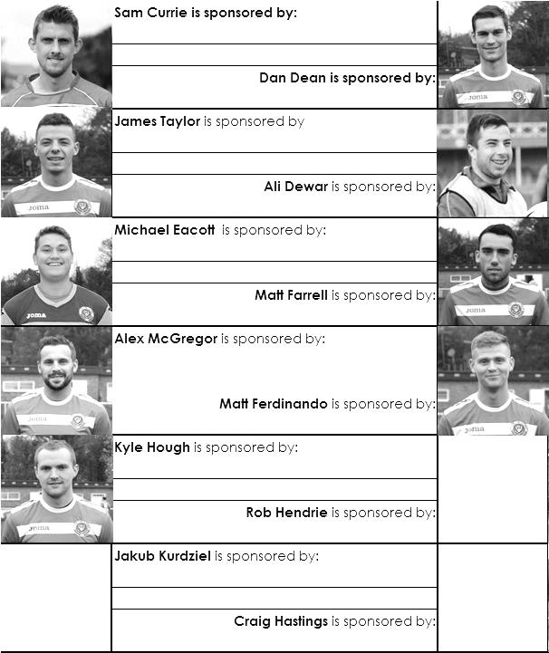

Here is the current list for the 2015/16 season showing all of our players and Management that are currently available for sponsorship this season. Pictures for our new players will feature shortly.

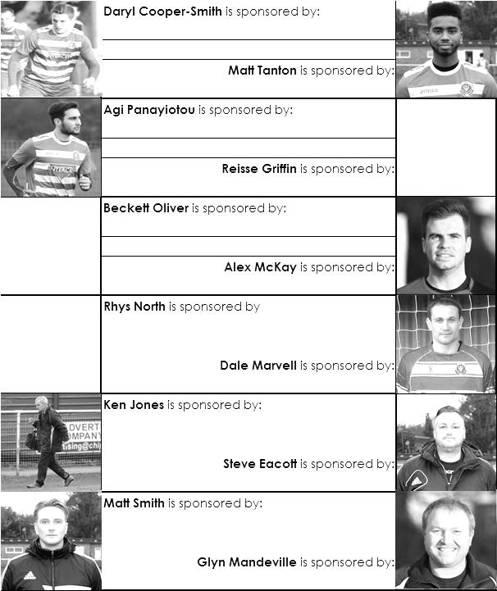
Sponsorship costs just £40 and it is easy to do. Just select a player who has not been previously sponsored and let a Committee Member know that you would like to sponsor them. Beware though. Until we have received the money it is possible for someone to jump in front of you, so don’t delay, act today!

Epsom & Ewell F.C. Club History 1918 - 2015
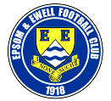
We were founded in March 1918 as Epsom Juniors Cricket Club and played throughout the summer. In the autumn, Epsom Juniors F.C. came into being and played a handful of games from what is now known as Alexandra Recreation Ground. Competitive football followed as we entered the Surrey Junior League in 1919, and became founder members of the Sutton & District League in 1920.

A change of name in July 1922 to Epsom Town F.C. heralded the start of a very successful era. By now resident at the Horton Hospital Sports Ground, we were unfortunate to lose 2-1 after extra time at Dorking F.C.’s Pixham Lane ground to Caterham Mental Hospital in a replay of the Surrey Junior Cup Final. However, we won three other trophies that season, the Leatherhead Hospital Shield, the Sutton Hospital Cup, and the Epsom Hospital Cup. In addition, we also won the Sutton & District League, and under the forward thinking of their visionary Chairman Hugh Bradley, took the step into Intermediate Football, where we won the Southern Suburban League without losing a match. Senior football was granted as we were unanimously accepted into the Surrey Senior League for 1924/25, where we finished third.

In September 1925, the club relocated to the old Ewell F.C. ground at West Street, which was purchased through the generosity of our future President Robert Bradshaw. In 1925/26 the Championship of the Surrey Senior League was attained, and the following season, we defeated Egham 1-0 at Egham in the League Charity Cup to complete a League and Cup “double”.

Election to the London League followed, and the title was claimed in the first attempt in 1927/28. Unfortunately, we were unable to repeat this, instead finishing runners-up in 1931/32, 1932/33, 1934/35, 1936/37 and 1937/38. Cup Honours were limited, although in 1929 Redhill defeated us 3-2 in front of 4,600 at Guildford in our first Surrey Senior Cup Final, having seen off Wimbledon 4-1 in the semi-final!

The thirties were a very successful era, and we won the Surrey Charity (Senior) Shield in 1933 with an impressive 5-0 win over Woking at Kingfield. However, the proudest moment of our pre-war history was an appearance in the First Round Proper of the F.A.Cup in 1933/34. Woking, Nunhead, Tooting & Mitcham, Beddington Corner, and Leytonstone were defeated, and a crowd of 9,485 at the Lea Bridge Speedway Stadium witnessed a 4-2 loss against the hosts Clapton Orient. At the end of that season we changed our name to Epsom F.C.

In 1939 a newly formed team, Epsom Town (no connection to the earlier name) shared the ground with Epsom F.C. However, this arrangement was suspended when war was declared, and we folded for the duration. In the meantime, Club Chairman Charles Pettett threw in his lot with Epsom Town in an attempt to boost morale by keeping the football flag flying. It was successful, as that club competed continuously throughout the war years, winning the Surrey Combination in 1939/40, and reaching the Surrey Senior Cup Final in 1944, losing 3-1 to Tooting & Mitcham, at Sandy Lane. After the war, Epsom F.C. restarted, continuing in the London League and reclaimed West Street. Temporary homes were found for Epsom Town while they competed for a season in the newly created Corinthian League, but disbanded in 1946.

In 1949 we entered the Corinthian League ourselves, where in 1952 we reached the League Memorial Shield Final in 1952, going down 2-1 to Champions Hounslow at Eastbourne after leading at half-time. Things improved further with the signing of the former English Amateur International Pat Lynch from Hendon, finishing third in 1952/53, while in 1954 we reached the Surrey Senior Cup Final for the second time in our history, losing unluckily 2-0 to Corinthian Casuals in front of 6,159 at Selhurst Park. In 1955 we won the Surrey Senior Shield with a 1-0 win over Carshalton Athletic at West Street.

We appointed our first ever Manager, Kingstonian legend Doug Whitehead in 1955 and the Corinthian League double was almost achieved in 1956/57, but two losses in the final week, along with a 2-0 defeat in the Cup Final to Maidenhead United at Dorking ensured that we ended with neither, finishing fourth. However in 1960, we finally raised the Shield with a 2-0 revenge win over Maidenhead at Vale Farm, home of Wembley F.C.

In 1960 we changed our name once again to Epsom & Ewell F.C. This was not because of any merger with Ewell & Stoneleigh as is often quoted, but was an attempt to increase support across the whole of the Borough. In 1963 the Corinthian League merged with the Athenian and Delphian Leagues, and we were placed in Division One of the new structure, but the sixties were full of poor results and we were relegated in 1965.

Despite a string of managers, most notably ex-Leyton Orient winger Jimmy Smith, and Tony Williams, now famous for his creation of the F.A. Yearbooks, our fortunes did not improve significantly and further relegations were avoided in the early seventies by the benefit of re-election. However in 1973, despite “improving” to finish second from bottom, the Athenian League ran out of patience and cut us loose. This was unfortunate timing as

we had just cleared all of our debts, and in addition to a virtually new Committee, former Fulham player Pat O’Connell had taken over as Manager.

The Surrey Senior League took us in at the last minute, and the new squad, including young striker Tommy Tuite, won the League Cup, and the following season, 1974/75 achieved a second Surrey Senior League “double”. However, the season would always be remembered for reaching the Final of the inaugural F.A. Vase, where 9,500 saw the Blues edged out 2-1 by Hoddesdon Town at Wembley Stadium. The Athenian League welcomed us back, and promotion to the top flight was achieved in that first season. In 1976/77 we reached the Athenian League Cup Final, losing 1-0 at Chalfont St Peter.

For 1977/78 many clubs were invited to join the expanding Isthmian League, and we were placed in the new Division Two. Our first match under floodlights took place against Met Police, and the title was clinched the following April. In 1979/80 we won the Southern Combination Cup 7-2 over Hampton on their own pitch, where the opposition were blitzed by five goals from Tuite. The following season a new clubhouse opened at West Street, and we finally won the Surrey Senior Cup, defeating Woking 2-1 at Tooting & Mitcham, although we just missed out on promotion. In 1983/84 we clinched a spot in the Premier Division as runners-up, although this time we missed out in the Surrey Senior Cup Final, defeated 4-0 by Sutton United at Imber Court.

With Adrian Hill as Manager since 1982, we survived comfortably in our first season at the new level, but Hill’s departure to Croydon in 1985 started a decline. Much of the squad left with Hill, and new Manager Alan Webb had too much to do. We were relegated in 1986, and following Webb’s departure soon after, Player / Manager Ricky Kidd nearly but not quite saved us from our second straight relegation. Adrian Hill replaced Kidd for a second spell at the helm in 1990, but we were placed in the new Division Three in 1991 in league reorganisation following a finish one position below the required half way mark.

In 1993 a large chapter in our history ended as we left West Street and moved in as tenants of Banstead Athletic. The decade was largely one of frustration, although we did reach the Final of the Associate Members Trophy, losing 2-0 to Bedford Town at Hendon’s old Claremont Road ground.

In 2002 Adrian Hill took us back up to Division 1 South, where we topped the table for a month, eventually finishing 9th, but Hill’s retirement at the end of the season led to relegation a year later and in 2006 we were transferred into the Combined Counties League Premier Division. In October 2006 Lyndon Buckwell, a former player became our new Manager, and in his first full season (2007/08) we were back in the top ten. In 2008/09 we exceeded this achievement and finished in fourth place after heading the table for a few months. In 2009/10 the club recovered from a slow start to finish fifth and also reached the last 32 of the F.A. Vase for the first time in 21 years, bowing out 3-2 in Northamptonshire to Long Buckby. In April of 2010 we terminated our seventeen-year ground sharing agreement with Banstead Athletic and spent two unspectacular seasons at Merstham F.C. before relocating to High Road, home of Chipstead F.C. for the 2012/13 season.

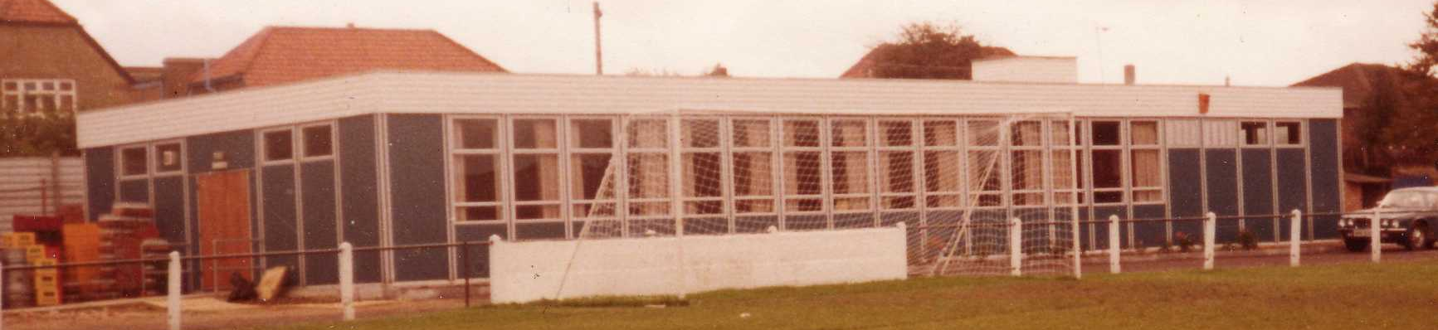
The season brought significant playing success as a slow start was followed by a spectacular run of form, including a club record 12 straight League wins, which put us at the top of the table for over a month before a tough run in resulted in a final position of fifth. However, any disappointment there was tempered by the club’s first silverware since 1981 when we defeated South Park 3-0 at Farnborough to win the Combined Counties League Cup. Lyndon also marked 300 games in charge of the club in early 2013. On a sadder note, 2012/13 also marked one thousand games and twenty seasons since we left West Street.

We carried our fine form into 2013/14 and led the league with eight straight wins but couldn’t hold on and had to settle for third place, our highest league finish since 1984, but the following season Lyndon Buckwell departed and Glyn Mandeville and new Assistant Matt Smith steered the club to seventh place, despite a substantial budget cut, and we continue at High Road for 2015/16.

Meanwhile, the search continues for a new ground back in the Borough…..

Spartan South Midlands League - Current Table 2015/16
including Tuesday 11th August | P | W | D | L | F | A | Pts | GD
Hertford Town | 2 | 2 | 0 | 0 | 8 | 3 | 6 | +5
Cockfosters | 2 | 2 | 0 | 0 | 6 | 1 | 6 | +5
Tring Athletic | 2 | 2 | 0 | 0 | 5 | 2 | 6 | +3
AFC Dunstable | 2 | 2 | 0 | 0 | 3 | 0 | 6 | +3
Welwyn Garden City | 1 | 1 | 0 | 0 | 6 | 0 | 3 | +6
Sun Sports | 2 | 1 | 0 | 1 | 6 | 2 | 3 | +4
Hadley | 1 | 1 | 0 | 0 | 3 | 0 | 3 | +3
Wembley | 1 | 1 | 0 | 0 | 3 | 0 | 3 | +3
Leverstock Green | 1 | 1 | 0 | 0 | 3 | 2 | 3 | +1
London Colney | 1 | 1 | 0 | 0 | 1 | 0 | 3 | +1
Berkhamsted | 2 | 1 | 0 | 1 | 4 | 4 | 3 | 0
FC Broxbourne Borough | 2 | 1 | 0 | 1 | 2 | 2 | 3 | 0
Biggleswade United | 2 | 1 | 0 | 1 | 1 | 2 | 3 | -1
London Tigers | 2 | 1 | 0 | 1 | 4 | 7 | 3 | -3
St Margaretsbury | 2 | 1 | 0 | 1 | 4 | 7 | 3 | -3
Holmer Green | 2 | 0 | 0 | 2 | 2 | 4 | 0 | -2
Stotfold | 2 | 0 | 0 | 2 | 1 | 3 | 0 | -2
Bedford | 1 | 0 | 0 | 1 | 1 | 4 | 0 | -3
Hoddesdon Town | 2 | 0 | 0 | 2 | 1 | 4 | 0 | -3
Colney Heath | 2 | 0 | 0 | 2 | 0 | 5 | 0 | -5
Oxhey Jets | 2 | 0 | 0 | 2 | 4 | 10 | 0 | -6
Harefield United | 2 | 0 | 0 | 2 | 1 | 7 | 0 | -6
Why are we covering the Spartan South Midlands League table today, you may ask!

Well, some clubs have links with other teams. Bracknell Town I can recall, covered a page in their programme a few years back devoted to Bayer Leverkusen as the two towns were twinned or something like that. I thought that if there was any team we should be keeping a look out for, it should be our old, or should that be new friends from Hoddesdon Town.

Many of you will be aware that we met in the first F.A. Vase in 1975 and of course renewed acquaintances by playing a friendly in July. From time to time we shall review the progress of the Hertfordshire club and see how they are getting on.

Right now, the short answer is, not well, having lost their opening pair of fixtures, but it should be remembered that Hoddesdon Town finished 19th last season, only five points ahead of the relegation spaces and have a new Manager with many new players too. It will take time and in due course I’m sure we’ll see them moving up the table.

They were due to be the first match of the entire F.A. Cup when they hosted Sawbridgeworth Town on Friday evening and although I was going up to the match, it is far too late to report for this programme, due to print deadlines. Here’s hoping they weren’t the first team out of the competition, which incidentally happened to us back on the Friday 25th August 1995, when Tooting & Mitcham defeated us 4-0 at Merland Rise.

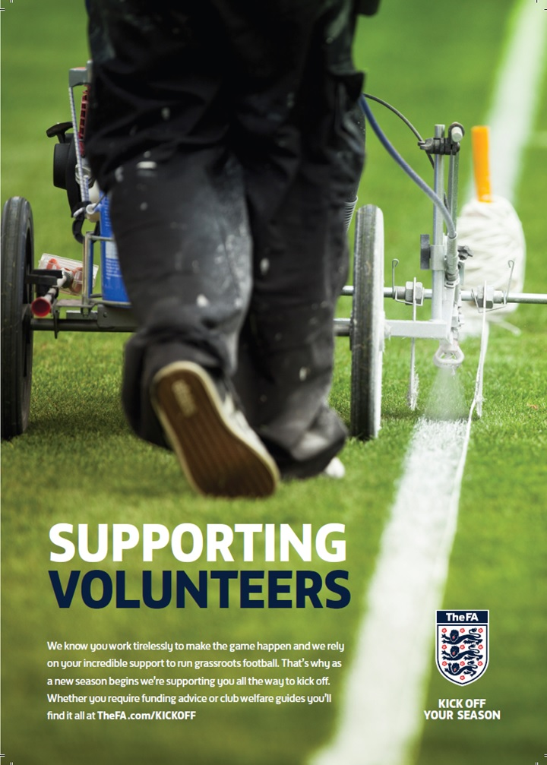

Combined Counties League – Premier Division
Sunday, 16th August 2015 - Kick-off 3.00 p.m.
Epsom and Ewell  (Royal Blue & White hoops) | V |  | Erith & Belvedere  (Red and White Quarters)
Squad | NUMBERS
Michael Eacott |  |  | George Kamurasi
© Sam Currie |  |  | Denzel Gayle
Matt Tanton |  |  | Rob Saunders
Dale Marvell |  |  | Ryan Johnson
James Taylor |  |  | Joe Vines ©
Dan Dean |  |  | George Benner
Matt Farrell |  |  | Mikey Dalton
Reisse Griffin |  |  | Colin Richmond
Kyle Hough |  |  | Alfie May
Daryl Cooper-Smith |  |  | Ramone McCrae
Matt Ferdinando |  |  | Chris Hubbard
Craig Hastings |  |  | Sam May
Beckett Oliver |  |  | Enoch Adjei
Jakub Kurdziel |  |  | Joe Minter
Rhys North |  |  | Jamie Taylor
Savva ‘Agi’ Panayiotou |  |  | Brett Ince
Alex McKay |  |  | Dean Nash
Rob Hendrie |  |  | Brendon Cass
Alex McGregor |  |  | George Luck
Glyn Mandeville | MANAGER |  | Matt Longhurst
Matt Smith | ASSISTANT |  | Bill Manners
Steve Eacott / Alex McKay / Ken Jones | COACHES / PHYSIO |  | Brendon Cass / Sonny Gladdish / Darren Mace / Kirsty Harding
REFEREE: J.Ohene (Brentford)
ASSISTANTS: T.Simmons (Shepperton), M.Oakes (Hillingdon)
Today’s Match and Ball are sponsored by
one of our Committee Members, Mike Lovett

OUR NEXT VISITORS TO HIGH ROAD
To be confirmed
Please keep checking our social media
and website for further details

